Project Proposal
For a Volunteer Management System

Tulsa Neighbors Market

Project Proposal Prepared By:
Anna Boevers, Trinyon Gaylor, Alexia Glory, Joe Pennington, Timothy Carlsson Seger, Jaden Worrell

Table of Contents
Milestone 1 5
Memorandum 6
SYSTEMS PROJECT PROPOSAL FORM 7
Statement of Scope 8
General Project Information 8
Opportunity/Problem Statement 8
Project Objectives 8
Project Description 8
Affected Users 9
Benefits 9
Constraints 9
Duration 9
Cost 9
Feasibility/Risk Assessment 10
Technical Feasibility -- 10
Economic Feasibility -- 10
Legal and Contractual Feasibility 10
Operational Feasibility 11
Schedule Feasibility 11
Overall Assessment of Feasibility 11
Strategic Assessment 12
Productivity 12
Differentiation 12
Management 12
Overall 12
Estimation Chart 14
Functions 14
Formulas 14
Project Schedule 16
Milestone 2 17
Memorandum 18
Statement of User Environment 19
List of Major Problems/Causes/Effects 21
System Objectives 22
List of Critical Assumptions 23
Assumptions about the system: 23
Assumptions about the continuation of the project: 23
Statement of User Requirements 24
Outputs 24
Inputs 24
Processes 25
System Performance 26
Outside of Scope 26
Recommendation 27
Milestone 3 28
Memorandum 29
Solutions 30
Hierarchy Charts 38
Entity Relationship Diagram 40
Monthly Volunteer Summary Report 41
Update Account 41
Data Store Report 42
Data Element Report 43
Process Report 46
Source/Sink (External Entity) Report 47
Data Flow Report 47
Alternatives 52
Purchasing Existing System 52
Develop a New System 53
Recommendation: 53
Milestone 4 54
Memorandum 55
Overview of Interface 56
Hierarchy Chart 56
List/Descriptions of All Programs 57
Prototypes of Outputs 58
Output Data Dictionaries 61
Prototypes of Inputs 67
Input Data Dictionaries 70
Prototype of Entire Navigation System 73
Appendix 74
M2 Appendix: Interview Request 75
M2 Appendix: Interview Reminder 76
M2 Appendix: Interview Agenda 77
M2 Appendix: Interview Summary Email 78
M2 Appendix: Interview Summary 79
M2 Appendix: Questionnaire Request 81
M2 Appendix: Questionnaire 82
M2 Appendix: Questionnaire Response 84
M2 Appendix: Sample Document 86

Milestone 1
Prepared for

Tulsa Neighbors Market

Prepared By Systems Analysis Team 2:
Anna Boevers, Trinyon Gaylor, Alexia Glory, Joe Pennington, Timothy Carlsson Seger, Jaden Worrell

Memorandum
To: Dr. Lori Leonard, Tulsa Neighbors Market
From: Anna Boevers, Trinyon Gaylor, Alexia Glory, Joe Pennington, Timothy Carlsson Seger, Jaden Worrell
Date: 24 September 2025
Subject: Milestone 1: Project Proposal – Volunteer Management System

Director Leonard:

Our team has reviewed your proposal for a Volunteer Management System (VMS) supporting Tulsa Neighbors Market (TNM) and believe we will be able to develop a system that supports the organization’s needs. This system will be designed specifically for this project, working to increase the capacity of neighbors that can be served daily, improve volunteer retention rate through streamlined volunteer management, and increase operational capacity within TMS.

Our team is here to answer any questions or concerns you may have about this project proposal. Please feel free to contact us at any time for additional information – we look forward to working with you!

Best,
Anna Boevers
Trinyon Gaylor
Alexia Glory
Joe Pennington
Timothy Carlsson Seger
Jaden Worrell

SYSTEMS PROJECT PROPOSAL FORM
Part I: To be completed by user

Date submitted: August 28, 2025 Request for: _____ Modification
of system

_____ Redesign of
system

__X__ New System

Submitted by: Lori Leonard Department: Director of Neighbors Market

Nature of request: Improve the volunteer sign up and registration, as well as reporting

Reason for request: As we have more and more need to provide food to the community, we need to have ample volunteers to assist. We currently do not have enough volunteers on certain days because volunteers are unaware of the need on those days.

Part II: To be completed by the systems analyst

Systems work required: ____ Minor ____ Moderate __X__ Major

Implementation will require: __X__ Software ____ Hardware ____ Personnel

New resources required: __X__ Minor ____ Moderate ____ Major

Feasibility factors score: T 9/10 E 10/10 L 9/10 O 8/10 S 10/10

Strategic factors score: P 10/10 D 5/10 M 10/10

Statement of Scope

General Project Information
- Project Name: Volunteer Management System
- Sponsor: Dr. Lori Leonard
- Team Members: Anna Boevers, Trinyon Gaylor, Alexia Glory, Timothy Carlsson Seger, Joe Pennington and Jaden Worrell

Opportunity/Problem Statement
Problems: Lack of consistency in number of volunteers on any given day; volunteers cannot sign up for shifts beforehand; difficulty managing volunteers; volume of neighbors often more than can be assisted; volunteers become discouraged.
Opportunities: Improved volunteer retention rate because of workload being distributed more equally; increased morale for volunteers as they won’t be treated as poorly if there are enough volunteers to service all neighbors; opportunity for information system overhaul.

Project Objectives
- Increased capacity of the number of neighbors that can be served daily
- Decreased waiting times for neighbors that come to the market
- Decreased number of volunteers that leave due to stress/discomfort
- Allowing TNM to remain operational and continue serving the community
- Allowing TNM to have 20 volunteers per shift

Project Description
The goal of this project is to develop a Volunteer Management System (VMS) to cure the ailments plaguing the current system (or lack thereof). This new system will allow the director to ensure that the required number of volunteers is present each day, and that volunteers don’t feel too overwhelmed by being understaffed. Furthermore, the data acquired from utilizing this system can be used to generate reports that will help the director to find the optimal number of volunteers for each day. By making these backend enhancements, the neighbors will receive better.

Affected Users
- Direct: Director, current/future volunteers, and volunteer coordinator
- Indirect: Neighbors and food donors

Benefits
- Tangible: Increased service capacity, higher volunteer retention rates, improved data and reporting
- Intangible: Increased volunteer worker morale and enhanced community relations

Constraints
- Legal: State obligations for protecting data, especially for minors, and compliance with laws
- Data accuracy: Dependency on volunteer compliance (sign-in/out)
- Resources: Software, hardware, and personnel
- Time: Milestone due dates and final project completion by 10 December 2025
- Budget: $25,000, Federal Budget Cuts may impact the budget allotted for our system

Duration
The project is estimated to be completed by 10 December 2025. Please see our Gantt chart in the Project Schedule section for an in-depth breakdown.

Cost
Estimated cost of this system is $24,368. Please see the estimation section for additional details.

Feasibility/Risk Assessment
A feasibility assessment evaluates the benefit and practicality an information system could bring to an organization. This assessment measures five factors of feasibility: Technical, Economic, Legal and Contractual, Operational, and Schedule (TELOS). This assessment will evaluate this project on each of the five factors and will measure the project’s overall feasibility and risk level. This evaluation will be measured on a scale of 1-10, with 1 being the least feasible and 10 being the most feasible.
Technical Feasibility -- 9/10
Technical Feasibility measures the technical ability of an organization to create and adopt a system. This can be measured by evaluating the project’s size, structure, development group experience, and ease of user group adoption. With an estimated 4.88-month timeline for our team of 6, the size of this project is within our timeline and technical capability. Our team is confident in our abilities to develop this project and have given Technical Feasibility a score of 9/10.
Economic Feasibility -- 10/10
Economic Feasibility is a cost-benefit analysis of the project, which measures the cost-effectiveness of the proposed solution to the organization’s problem. With an estimated budget of $18,942, our team is well within the project budget of $25,000 with plenty of room to spare. Even with delays or setbacks, we have the capacity to complete this project. This project will serve an extremely important purpose within the organization, and our team believes that its benefits will be immediately visible. For these reasons, the Economic Feasibility score is 10/10.
Legal and Contractual Feasibility -- 9/10
Legal and Contractual Feasibility is a measure of the legal constraints and contractual obligations under consideration in the proposed project. One legal requirement that the project team will need to consider is how to protect the data of any child volunteers under 18 years old and will have to be compliant with data collection laws related to children under 13 years old. The system will also have to handle and protect all proprietary volunteer information regardless of volunteer age. Other than this important consideration, our team does not foresee any other major legal or contractual issues. This results in a feasibility score of 9/10 for Legal and Contractual Feasibility.
Operational Feasibility -- 8/10
Operational Feasibility evaluates how well the solution will be received, adopted, and implemented within the organization. This covers both the employee morale aspect of implementing a new system and the practical functionality of the system. As with most new systems, there will likely be internal discomfort due to the learning curve. However, because the issues presented by the director are increasingly prevalent, we believe that the system will be a welcome improvement. This system will likely be utilized by a diverse group of people, ranging from TNM employees to frequent volunteers to first-time volunteers, and must be useable for all system users. For these reasons, we give Operational Feasibility a score of 8/10, because while the transition may not be completely smooth, we believe that its impact and the system improvements it offers will be accepted by all users.
Schedule Feasibility – 10/10
Schedule Feasibility relates to the projected project schedule and how achievable the milestones set in the schedule are for the project team. Given the Gantt chart developed by our team, the pre-determined milestone deadlines, and the organization of our project, we believe that the project will stay on schedule. For these reasons, we have given Schedule Feasibility a score of 10/10.
Overall Assessment of Feasibility -- 9.2/10
The Overall Assessment of Feasibility for this project is a culmination of the other 5 TELOS factors and represents how feasible our team believes this project is. Given our team’s project estimates, experience, and the impact this project will have on the organization, we give this project an overall score of 9.2/10.

Strategic Assessment
The purpose of the strategic assessment is to evaluate how well the project aligns with the purpose and goals of a company. The assessment will be made from 1 to 10, with 10 aligning perfectly and 1 being no alignment with the company’s objective. General factors of assessment will be productivity, differentiation, management and overall fit.
Productivity -- 10/10
Productivity relates to how well the proposed project will improve the productivity of the users. The system eliminates the attendance uncertainties that TNM previously had, allowing advance scheduling. With this system the TNM can have consistent coverage of all their shifts, therefore improving their productivity and reducing the problem of volunteer burnout.
Differentiation -- 5/10
The differentiation of a system quantifies how well the proposed project will differentiate the company from its competitors. Most volunteer opportunities have some form of check-in and reporting system, so the purpose of this system is not revolutionary or particularly unique. While the system will be tailored to fit TNM’s needs, efficiently balancing food distribution, shift coverage, and integration of neighbor check-in, the system is not groundbreaking. It will improve efficiency but will not be differentiated from the market in a significant way. For these reasons, we have given differentiation a score of 5/10.
Management -- 10/10
The management score demonstrates how well the proposed project will improve the management of the organization and its information. The system aligns perfectly with the current needs of TNM, by providing a visible schedule of volunteers, neighbor flow and workload distribution. This will help the management manage the volunteers, reducing the overwork problem and promise the customers smoother operation.
Overall -- 8.3/10
The limited differentiation is a drawback; however, the system's productivity and management goals makes the system create significant value. With a score of 8.3/10, the system aligns with the objective to a high degree, with the mission of providing reliable food assistance and keeping a sustainable volunteer base.
Project Estimates
Estimation Chart
Functions | Optimistic | Most Likely | Pessimistic | Expected | $/line | Line / Month | Cost | PM | Team PM
Volunteer Scheduling & Shift Management | 800 | 1040 | 1400 | 1060 | 4 | 1,000 | $4,240 | 1.06 | 0.17
Shift Notifications | 400 | 460 | 600 | 472 | 4 | 1,000 | $1,888 | 0.472 | 0.07
Volunteer/ Shift Database | 1600 | 2440 | 2800 | 2360 | 4 | 1,000 | $9,440 | 2.36 | 0.39
Volunteer Profiles & Attendance | 1200 | 1480 | 2000 | 1520 | 4 | 1,000 | $6,080 | 1.52 | 0.25
Volunteer Reporting | 500 | 650 | 730 | 680 | 4 | 1,000 | $2,720 | 0.68 | 0.11
Totals |  |  |  | 6092 |  |  | $24,368 | 1.82 | 0.99

Functions
- Volunteer Scheduling & Shift Management – volunteers can sign up in advance, caps out at 20 volunteers, admin can see shift rosters, core problem
- Shift Notifications- will send volunteers automated notifications related to open shifts
- Volunteer/Shift Database – stores volunteer account info and shift location, dates, and capacity
- Volunteer Profiles & Attendance – identities for each volunteer, attendance tied to identity, enables accurate tracking.
- Volunteer Reporting – admin may generate a report based on volunteer/shift database

Formulas
The table above uses the decomposition method of estimating, designed around using LOC (lines of code) to approximate size of project, rough idea of manpower required for each function, and the costs that will be incurred over the development process. Each function’s estimated LOC is calculated using a weighted average formula – for increased accuracy, “Most Likely” is given four times the weight of the other two estimates (Optimistic and Pessimistic).
Estimated LOC = (Optimistic+4*Most Likely + Pessimistic)/6
The estimated cost for each function, and the total project cost, can be calculated using the expected LOC for each function multiplied by the cost per line, which is $4 in this particular project. The overall cost, in this case, is each function added together ($4,240+$1,888+$9,440+$6,080+$2,720) is $24,368. This cost satisfies the budget while funding greater quality of functions.
Estimated project Cost ($) = Expected LOC*($/line)
PM (Person Month) describes the number of months one person would take to complete each function of the project. Expected LOC is multiplied by Line/Month, which is set at 1,000 for this project, to get the PM value required for a particular function, then divided by 6 for the Team PM value. The total PM value for this project is 1.82, reflecting a relatively fast timeline of completion.
Estimated effort Required (PM) = (Expected LOC)(Line/Month)
Team PM = PM/6

Project Schedule
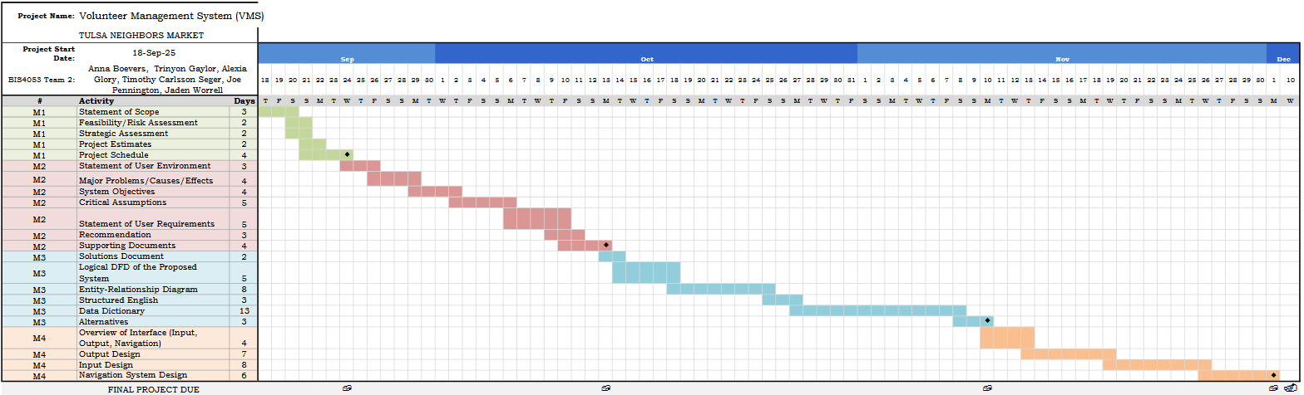

Milestone 2
Prepared for

Tulsa Neighbors Market

Prepared By Systems Analysis Team 2:
Anna Boevers, Trinyon Gaylor, Alexia Glory, Joe Pennington, Timothy Carlsson Seger, Jaden Worrell

Memorandum
To: Dr. Lori Leonard, Tulsa Neighbors Market
From: Anna Boevers, Trinyon Gaylor, Alexia Glory, Joe Pennington, Timothy Carlsson Seger, Jaden Worrell
Date: 13 October 2025
Subject: Milestone 2: Analysis of Current Volunteer Management System

Director Leonard:
The systems analysis team has spent the past few weeks examining the user environment, determining system requirements, conducting interviews, distributing questionnaires and gathering documents to build a volunteer management system best suited for the Tulsa Neighbors Market (TNM).

We have examined the processes at TNM and have broken them down into inputs and outputs. Additionally, we have created statements for both the current user environment and the requirements that pertain to this system. Lists have also been created for problems in the current system, as well as the associated critical assumptions. Finally, we have laid out the objectives we have and the quantitative goals we hope to achieve with this new system.
The systems analysis team would like to thank you for your assistance in analyzing the current state of the TNM system and we look forward to working with you in the future.

Best,
Anna Boevers
Trinyon Gaylor
Alexia Glory
Joe Pennington
Timothy Carlsson Seger
Jaden Worrell

Statement of User Environment
Tulsa Neighbors Market (TNM) is a long-standing local nonprofit organization dedicated to assisting “neighbors” in need. For many years, TNM has provided essential food assistance to hundreds of individuals and families in the Tulsa community. The market operates Monday through Friday from 9:00 AM to 2:00 PM and serves more than 100 neighbors per day. However, since the COVID-19 pandemic, TNM has experienced a significant increase in the number of neighbors seeking food assistance while simultaneously facing a reduction in available food due to recent federal budget cuts. As a result, the organization now provides food assistance once every other month per household instead of monthly. Neighbors are required to present identification and a list of all household members before receiving food. Food items are categorized and are donated by producers or local grocery stores, often as items near expiration. Assistance is provided on a first-come, first-served basis.
Volunteers are the backbone of TNM’s operations. They greet neighbors, guide them through the market, and ensure the process runs smoothly. TNM strives to provide quality service to every neighbor, but inconsistent volunteer attendance has become a major operational challenge. The organization aims to have 20 volunteers per shift, with three daily shifts: 8:30–10:30 AM, 10:30–12:30 PM., and 12:30–2:30 PM. Volunteers may serve in one or more shifts throughout the day. Despite this goal, there are frequent fluctuations in volunteer turnout. Some days have far more than 20 volunteers, while others have significantly fewer. When volunteer numbers are low, those present are often overwhelmed, leading to burnout and decreased retention. Conversely, an overabundance of volunteers can make individuals feel unnecessary, discouraging them from returning. Volunteers are never turned away, but this inconsistency directly affects TNM’s efficiency and service quality.
Currently, volunteers do not sign up in advance. They simply arrive for their preferred shift and complete a paper sign-in sheet upon arrival, providing their name, address, phone number, email, and hours volunteered. Each day requires a new sign-in sheet. Volunteers under the age of 16 must be accompanied by an adult who also signs in. Currently, there is no difference in how children’s data is stored compared to adult data. Just before each shift begins, the Director, Lori Leonard, assigns duties in either the market or warehouse. At the end of the shift, volunteers leave without signing out. Groups, often from churches, schools, or corporations, may call ahead to indicate their planned volunteer time, but all members are still required to sign in individually on-site.
Volunteer reporting and recordkeeping are limited and manual. The Director transcribes volunteer information from the sign-in sheets into a spreadsheet, but the data is often incomplete, inconsistent, or duplicated when volunteers serve multiple times. No computer-generated reports currently exist. The Director attempts to manually track daily and monthly volunteer numbers, but the process is time-consuming and prone to error. TNM does not retain volunteer information long-term. While email communication occasionally occurs with past volunteers for general updates, contact information is not stored or used for targeted recruitment during periods of volunteer shortages.
Because TNM lacks an organized volunteer management system, several problems have emerged. The inability to predict or balance volunteer attendance creates inefficiencies and volunteer dissatisfaction. Without proper tracking, it is difficult to recognize or reward consistent volunteers or identify active partner organizations. These operational gaps risk more severe consequences, such as neighbors being turned away or even temporary market closures due to inadequate staffing.

List of Major Problems/Causes/Effects
Ranking | Problem/Opportunity | Causes | Effects
1 | Volunteers do not have an opportunity to sign up before arriving at a shift. | Lack of a standard online system to sign up to volunteer for a shift. | Shifts are often understaffed or overstaffed due to a lack of planning.
2 | Volunteers are overwhelmed or feel unneeded. | No sign-up system exists for volunteers before they arrive at TNM. | Volunteer retention rate decreases, and TNM may not be able to run effectively.
3 | Volunteers being improperly managed and moved around during shifts. | Lack of visibility into the number of volunteers necessary for a shift and where they go. | Volunteer retention rate decreases, and fewer neighbors may be served.
4 | Creating standards for data collection to ensure accuracy and consistency amongst all sources. | No data validation is in place when volunteers are inputting information during sign-in. | Accurate reports cannot be generated and used to make strategic decisions.
5 | A new data governance framework that controls children’s data. | No additional controls around children’s data. | Limited legal liability regarding children’s data handling.
6 | Improving the reporting capabilities of the director of the TNM to provide them accurate information for decision-making. | The current process has no data standardization or governance. | Greater visibility for each volunteer and the ability to make data driven decisions.

* Rankings range from 1-6 with 1 being the most important opportunity and 6 being least important.

System Objectives
- The market will have 20 volunteers per shift 95% of the time.
- The system will enable 90% of shifts to be filled one week in advance.
- The market will serve over 100 Neighbors every day.
- The system will allow 100% of Volunteers to receive reminders 24 hours before their shift.
- The market will retain up to 25% more Volunteers.
- The system will allow Volunteer information to be managed at least 45 minutes faster.
- The system will send weekly shift information to at least 80% of previous volunteers.
- The system will provide at least 4 new reports for management.

List of Critical Assumptions

Assumptions about the system:
- The new Volunteer Management System (VMS) will successfully address the current issues of inconsistent volunteer numbers, lack of advanced sign-up, and difficulty managing volunteer scheduling, capacity management, and data-driven reporting.
- The system will be adopted and used effectively by a diverse group, including the director, volunteer coordinators, current and future volunteers, with acceptance despite an initial learning curve.
- The system will comply with legal requirements related to data protection, especially for volunteers under 18 years old, including children under 16, and will safeguard proprietary volunteer information.
- Volunteer compliance with sign-in and sign-out will be sufficient to ensure data accuracy for reporting and management.
- The system will require new software, hardware, and personnel resources at moderate levels.

Assumptions about the continuation of the project:
- The project will be completed by the scheduled deadline, December 10, 2025, with milestones achievable within the planned timeline.
- The budget of $25,000 will be enough to cover the system development costs.
- The project will continue because there is an increasing need for volunteer assistance to meet the growing demand for food provision to the community.
- Stakeholders, including Director Leonard and the Tulsa Neighborhood Market organization, will maintain their support and commitment throughout the project lifecycle.
- The system improvements will be accepted and have a positive impact on volunteer retention, neighbor service capacity, and operational stability, justifying the project's continuance.

Statement of User Requirements

Outputs
- The system should allow a printed schedule showing what volunteers are scheduled for each shift for volunteer use upon check-in
- The system should allow an online display showing shifts and the number of spots that are available for each shift for a four-week period.
- The volunteer sign-ups system should display the time slots that are available but put a limit on 20 volunteers for a shift. However, walk in volunteers are always allowed.
- After signing up, the system should automatically send an email confirmation to the volunteer or group contact confirming their time as well as including an instruction on how to cancel or change time.
- The system should allow volunteers to modify and update their current contact information.
- The system should allow volunteers to modify the date and time of their upcoming volunteer shift.
- A dashboard should be displayed, the dashboard should show the volunteers sign up in totals by each time slot, furthermore, also show the sign-ups for four weeks in advance.
- Reports must include:
  - Volunteer totals
  - Unique volunteers for each month
  - Breakdown of individual or group volunteer hours for the month
  - Breakdown of the number of shifts that have been overstaffed, fully staffed, and understaffed

Inputs
- A website that allows volunteers sign ups
- Volunteers must be able to sign up for multiple shifts a day across multiple days.
- Individuals must have an account to be able to sign up as volunteers and update their information.
- Volunteers who are under the age of 16 must have an adult sign up for them that are linked to the child thought their account. The child's name and age should be entered.
- Volunteer sign-up and update ability must include:
  - Number of volunteers
  - Volunteer name, address, phone, email
  - Organization/church/school they represent (if applicable)
  - Option to add multiple minors tied to the adult volunteer.
- An iPad should be used to check in and out of shifts. Volunteers should themselves sign in and out of the shift.
- In case of group sign-ups, only one single ID and password are used, and one person is a contact person and log in when group arrives at TNM.

Processes
- The new system will automate the sign-in and sign-up times.
- Sign-ups for children under 16 should be linked to adult account ID.
- Systems must help to balance the volunteer load using sign up limits and dashboard alerts by updating time slots available.
- The system will effectively store the contact information of volunteers to easily be able to reach out when needed
- Volunteers will be sent emails automatically.
- Volunteers will be able to update contact information.
- The system will be able to produce current volunteer contact information to be updated.
- The system will be able to produce a list of available time slots.
- The system will automatically update a list of dates and times available for volunteer shifts.
- The system will be able to process a group signup.
- The system will have an automatically updating dashboard with relevant reports and information.
- The system will be able to process marked arrivals and departures at TNM by the volunteers.
- The system must support monthly reporting without the entry of data manually.
- The system will produce a monthly report containing volunteer totals.
- The system will produce a monthly report containing the amount of unique volunteers for each month.
- The system will produce a monthly report containing a breakdown of individual or group volunteer hours for the month.
- The system will produce a monthly report containing a breakdown of the amount of shifts that have been overstaffed, fully staffed, and understaffed

System Performance
- The system must be user-friendly.
- The number of unique volunteers and volunteer totals are automatically reported monthly.
- Reporting individual volunteer hours.
- Secure handling of data which only director can access.
- Easy to use and reliable system for hours of operation.
- Reports should be generated automatically on the first of the month.
- Only the director should have access to reporting.
- The system should display four weeks of time slots for volunteering.
- The system should be able to add multiple minors per adult.
- The system should tie minors to the corresponding adult data.
- The system should allow groups containing multiple people to sign up.
- The system should limit each time slot to 20 volunteers.

Outside of Scope
- Managing neighbors.
- Managing employees who work at the market daily.
- Managing food inventory.

Recommendation
Our team recommends continuing with the Volunteer Management System for Tulsa Neighbors Market for the following reasons: Our Expected LOC (6092) multiplied by our $/line ($4) equates to a total project cost of $24,368. This figure satisfies the given budget of $25,000. This team’s Gantt schedule from Milestone 1, which provides a visual representation of the estimation of how long the project will take, supports the conclusion that our team will complete this project before the given time constraint. Our team’s TELOS analysis score averaged 9.2, with the lowest score being an 8/10 (Operational), reflecting high project feasibility across the board. The proposed system shall overhaul the way Tulsa Neighbors Market manages their volunteers, which will save the time and energy of employees/volunteers. Most importantly, however, the Volunteer Management System will allow for higher quality, more efficient, and more caring services to the Neighbors.

Milestone 3
Prepared for

Tulsa Neighbors Market

Prepared By Systems Analysis Team 2:
Anna Boevers, Trinyon Gaylor, Alexia Glory, Joe Pennington, Timothy Carlsson Seger, Jaden Worrell

Memorandum
To: Dr. Lori Leonard, Tulsa Neighbors Market
From: Anna Boevers, Trinyon Gaylor, Alexia Glory, Joe Pennington, Timothy Carlsson Seger, Jaden Worrell
Date: 9 November 2025
Subject: Milestone 3: Analysis and Logical Modelling of Volunteer Management System

Director Leonard:
Upon review of the system’s characteristics, our project team developed logical models while analyzing the system’s requirements. These actions cultivated our team’s overall understanding of the Volunteer Management System (VMS). After further definition of the project, we have consolidated our findings into documents that, we hope, will illuminate the analysis and logical design phases of our proposed system.

This deliverable serves as a container of a solutions document, an ER diagram, several DFD diagrams, and a dictionary containing all relevant data pertaining to the system’s processes as well as the entities involved in our Volunteer Management System.

It is our hope that this proposed system completely satisfies your requirements and we are thrilled to help your organization improve the aid it provides to our Neighbors. If any questions arise, please do not hesitate to contact us.

Anna Boevers
Trinyon Gaylor
Alexia Glory
Joe Pennington
Timothy Carlsson Seger
Jaden Worrell

Solutions
- Volunteers are unable to sign up for a shift prior to arriving on their shift due to the lack of a Volunteer Management System that can track and manage shift availability.
  - The system will allow volunteers to create an account on the VMS prior to scheduling a shift. This will allow them to have a centralized place where they can see all shift availability and information.
  - The system will actively update shift availability based on individual and group signups and the needs of TNM per day.
  - Volunteers will be able to log into their account on the website, search the available time slots, and sign up for a volunteer shift prior to volunteering.
- Because of the inconsistency in the number of volunteers per shift, shifts that are understaffed result in the few volunteers feeling overwhelmed or the extra volunteers feeling unneeded.
  - The system will manage volunteer time slot signups and will cap the number of volunteers signed up for a certain shift to 20 volunteers per shift.
  - Volunteers will not be able to sign up online for shifts that are already full, ensuring that there will be sufficient work for each volunteer. Although, even if the shift time is full, walk-ins will never be turned away.
- Due to the inconsistent number of volunteers per shift, volunteers and staff members may be moved around to other tasks rather than what they signed up to do.
  - With the implementation of the VMS system, TNM will be able to see in advance which time slots are understaffed. This will allow the employees at TNM to prepare to fill in where needed, ideally keeping volunteers where they want to be.
- Data is currently being recorded inconsistently and inaccurately, due to an unstandardized system of data collection.
  - With sign-ups, check-in and check-out, reporting, and contact information all entered and stored through the VMS system with data validation used to ensure data integrity, data collection will be standardized and ultimately more accurate.
  - When volunteers enter their contact information, data validation systems will be used to reduce mistakes and redundancies in data.
  - Volunteers will also be able to update their own personal information and volunteer sign-up, reducing the amount of data entry that employees will have to do.
- There is not a current data governance framework to protect the data of volunteers under the age of 16.
  - Volunteers who are under the age of 16 must have an adult sign up for them that are linked to the child through their account.
- The director of TNM does not have sufficient reporting capabilities due to insufficient technology and lack of data validation to produce accurate reporting.
  - The VMS will include reporting capabilities that include volunteer totals, unique volunteers for each month, a breakdown of individual or group volunteer hours for the month, and a breakdown of the amount of shifts that have been overstaffed, fully staffed, and understaffed.
  - Data validation practices will protect against incorrect data affecting the quality of the system’s reporting capabilities.
Data Flow Diagram

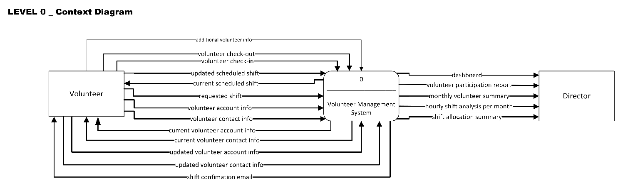
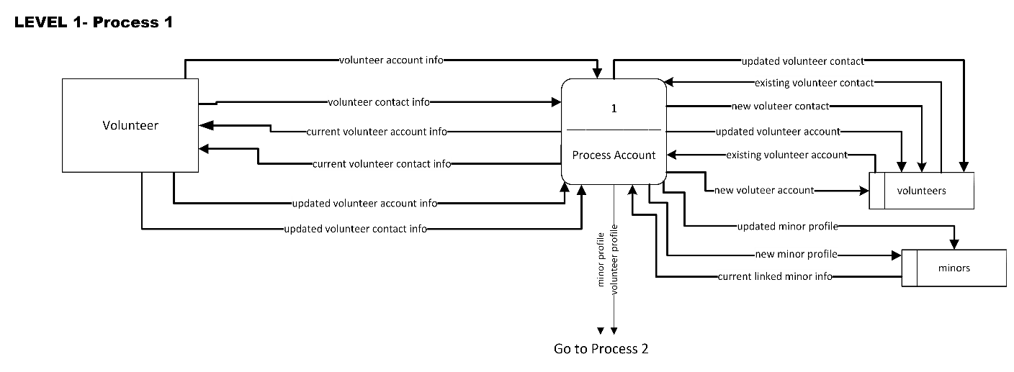
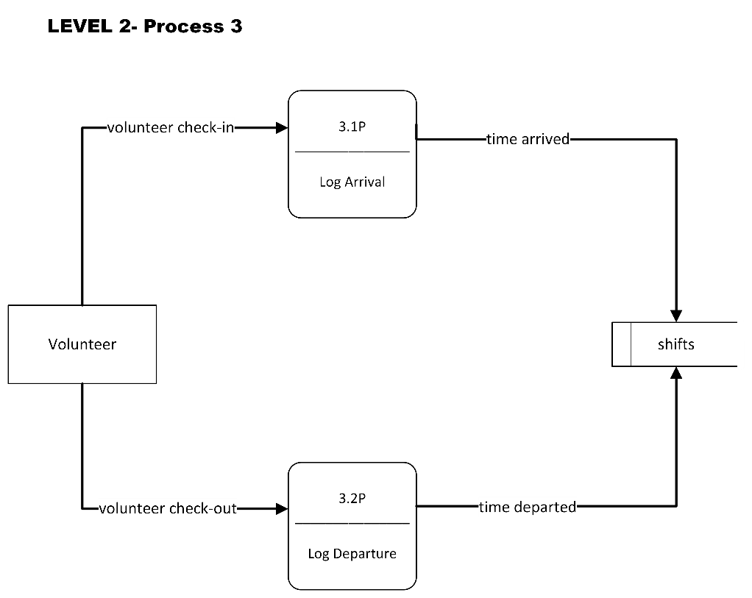
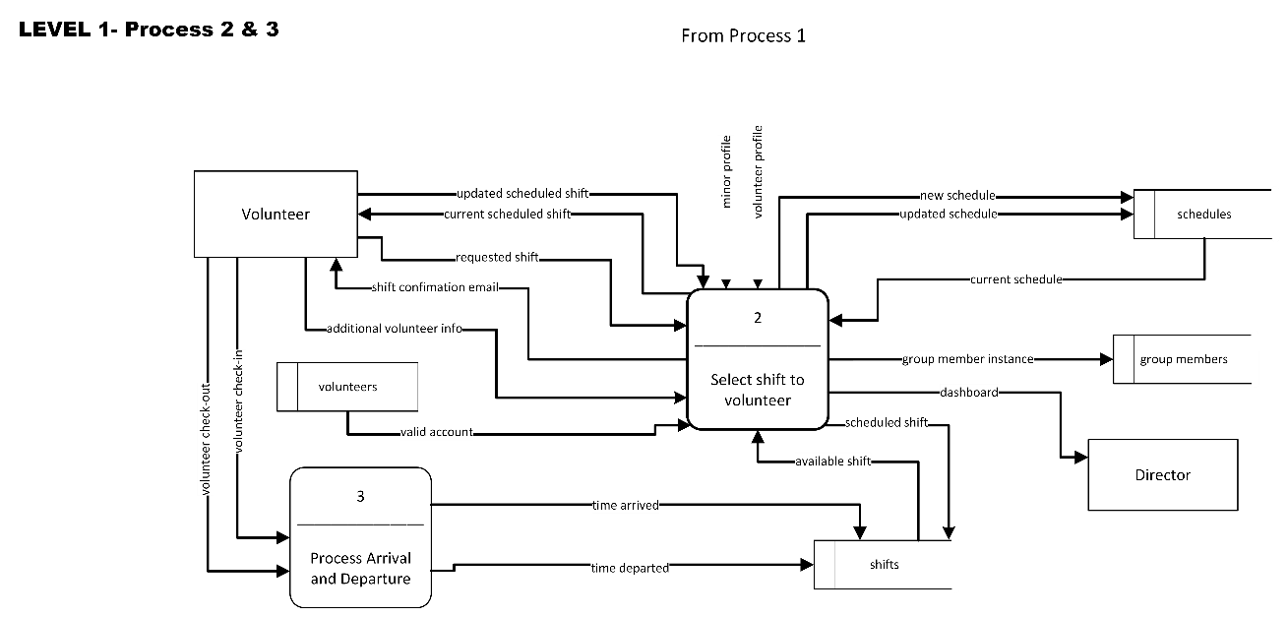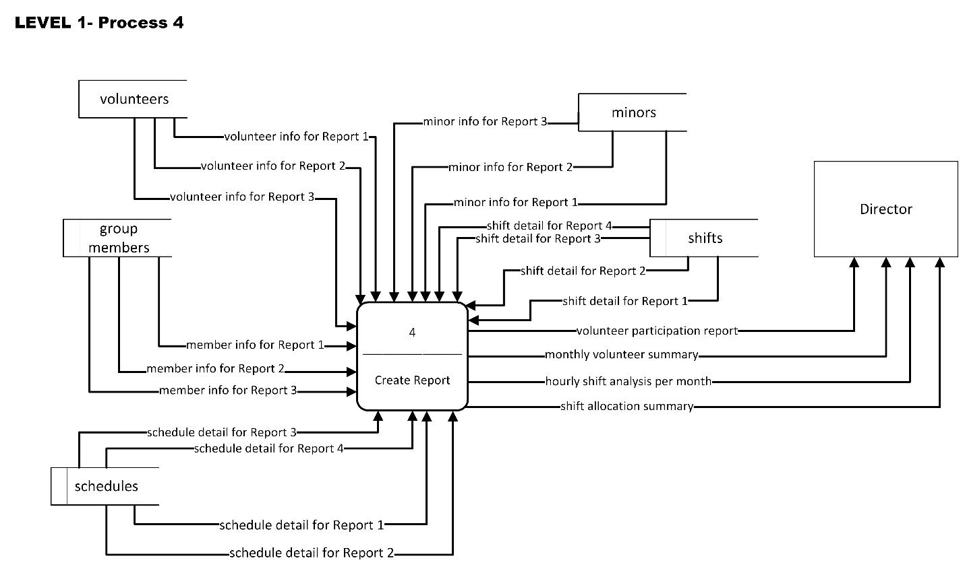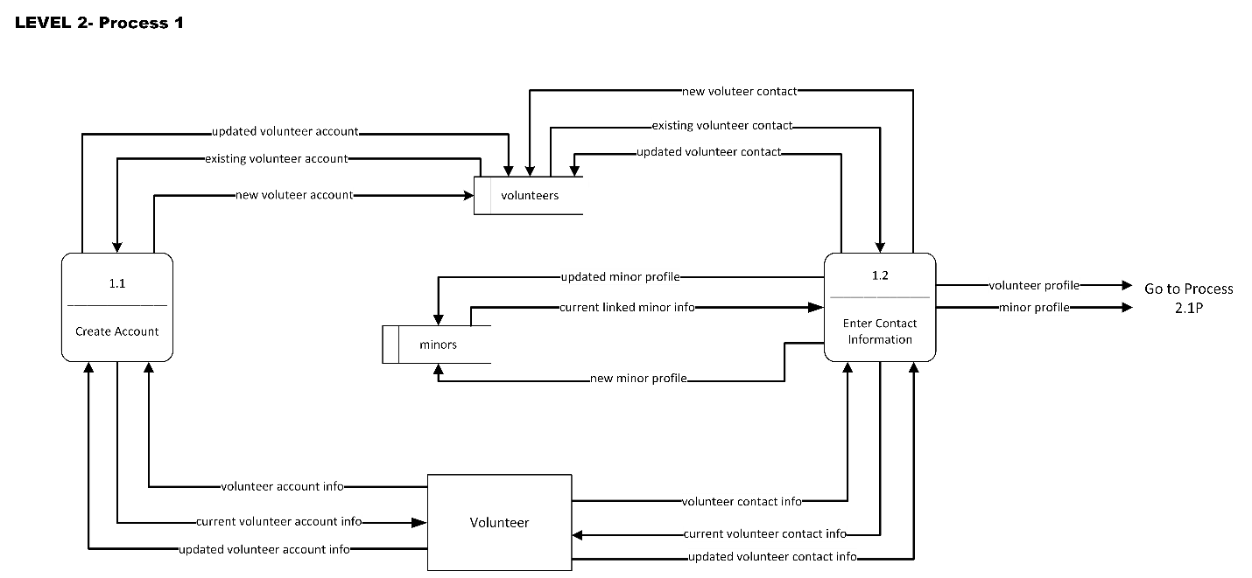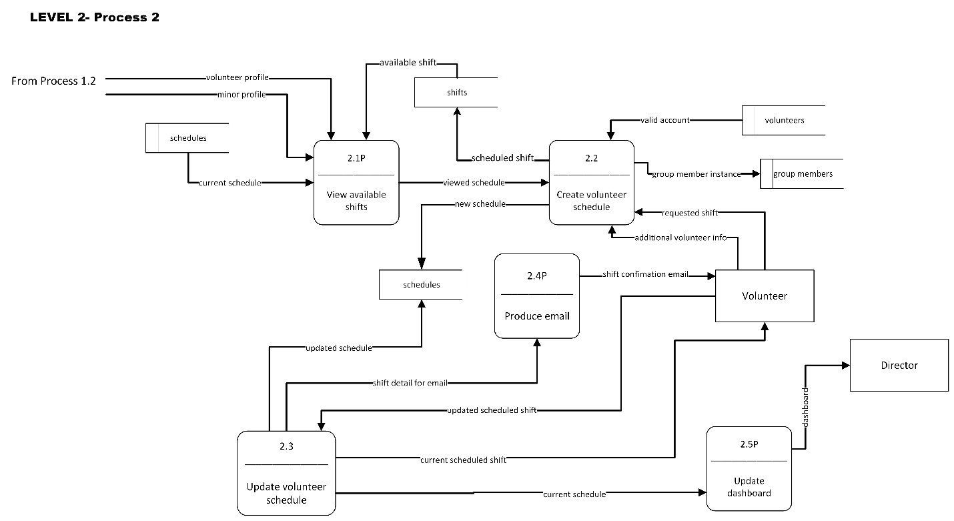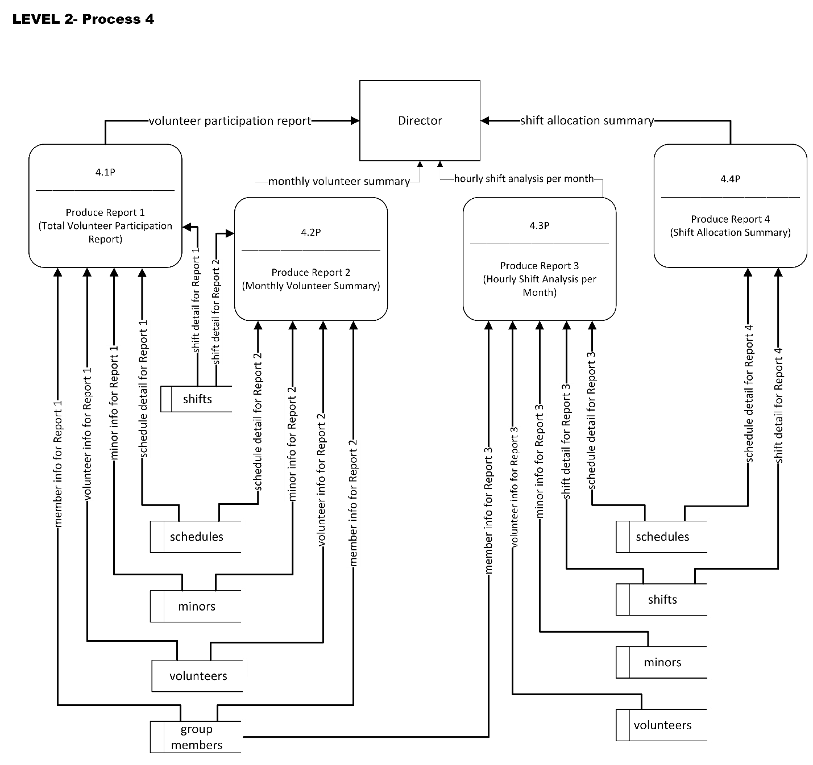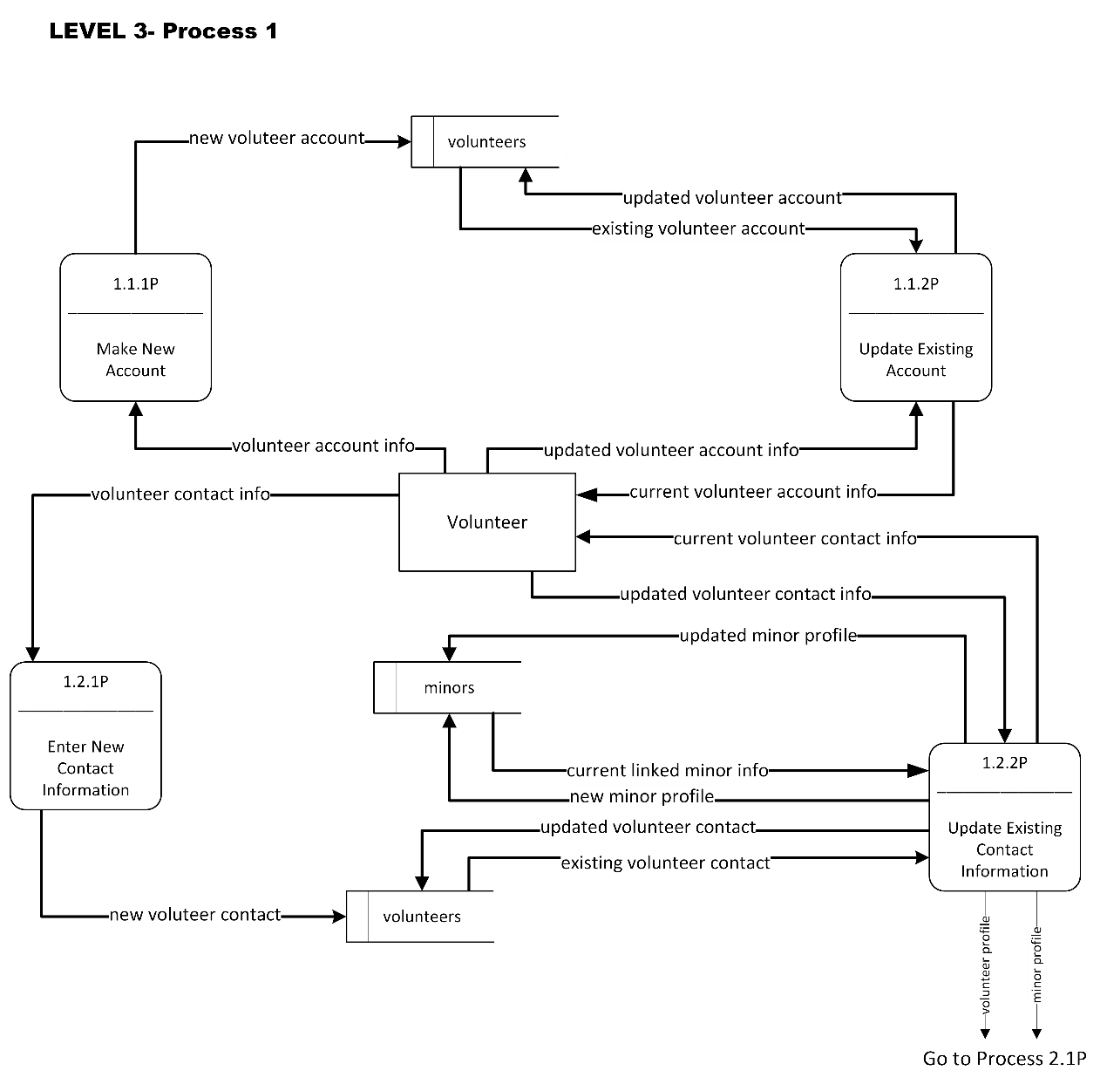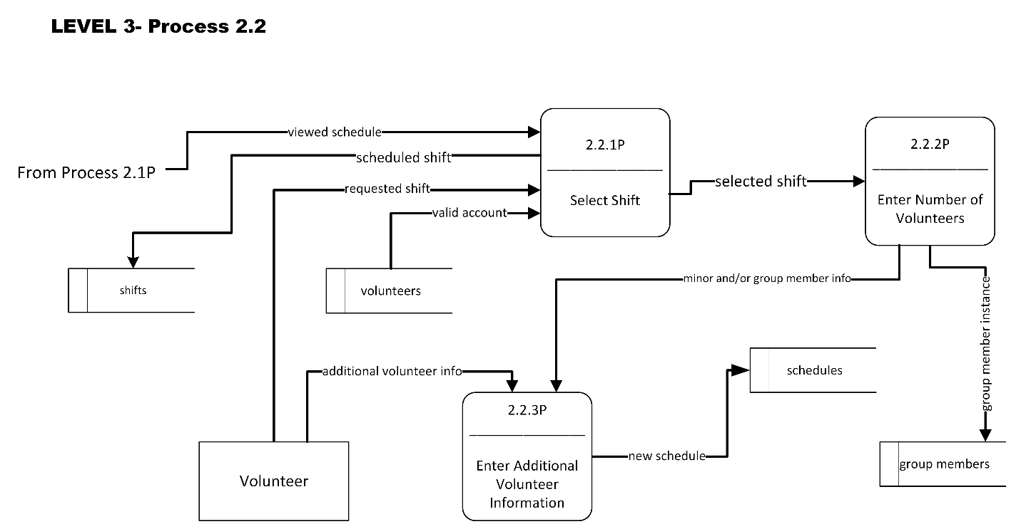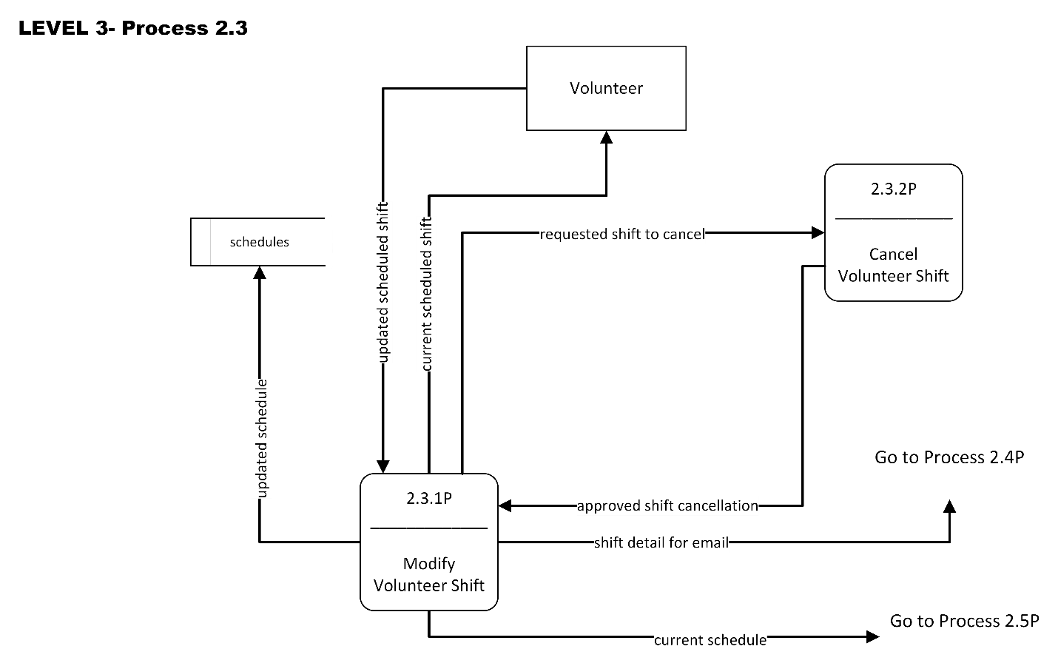

Hierarchy Charts

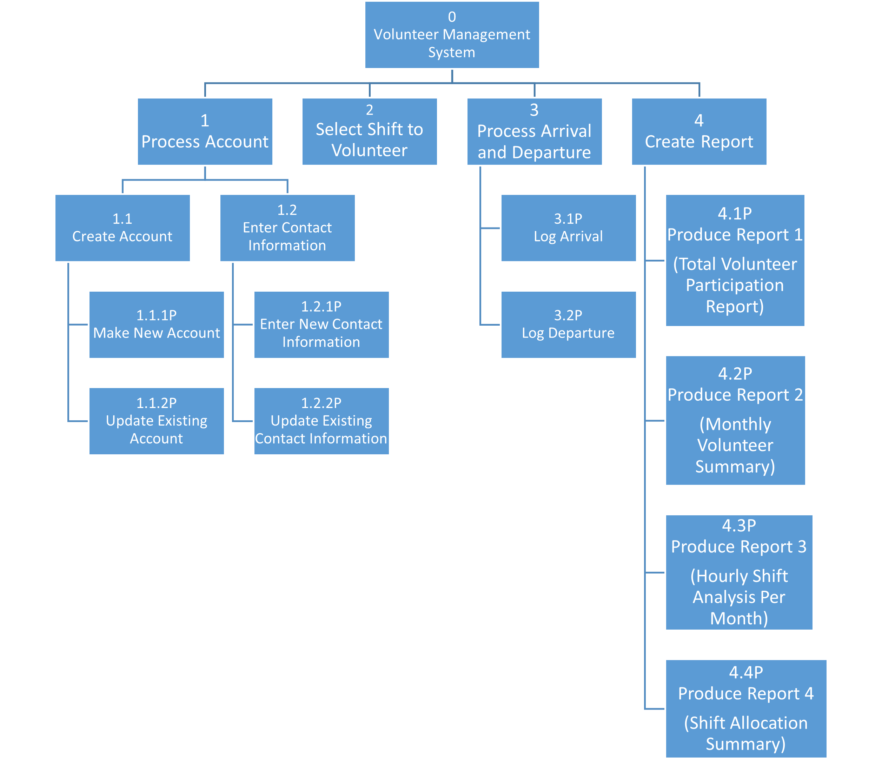
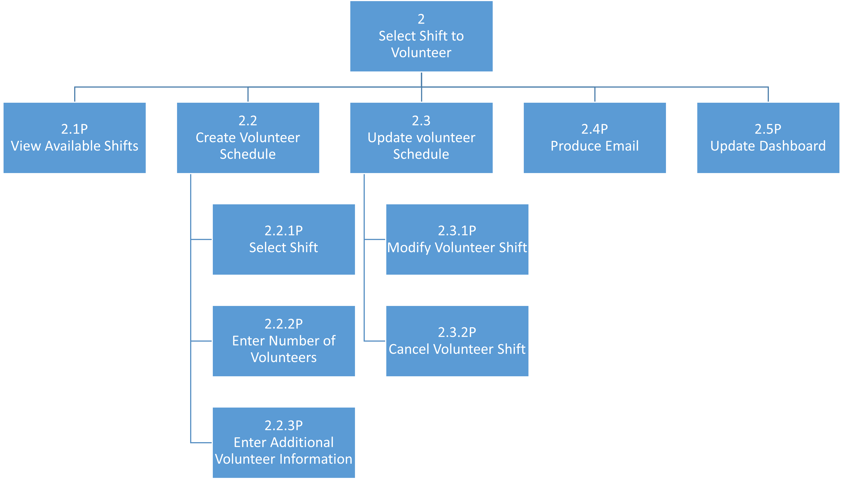

Entity Relationship Diagram
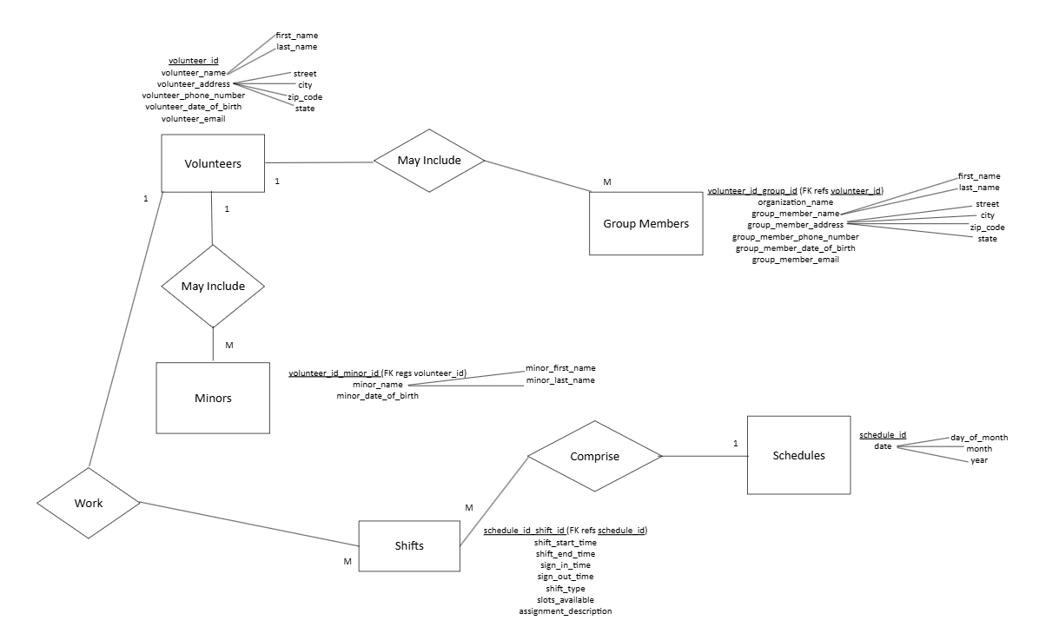
Structured English

Monthly Volunteer Summary Report
Process 4.2P – Produce Report 2 (Monthly Volunteer Summary)
Do
Find volunteer_id, volunteer_name, volunteer_email from Volunteers Data Store
If shift_start_time and date_month of volunteer_id was this month
Add volunteer_name and volunteer_email to Report
For volunteer_name on Report
Return the total of Names
Until end-of-file

Update Account
Process 1.1.2P Update Existing Account
Do
Find volunteer_id, volunteer _name_first_name, volunteer _name_last_name, volunteer_address_street, volunteer_address_city, volunteer_address_zip_code, volunteer_address_state, volunteer_ phone_number, volunteer_date_of_birth, volunteer_ email, from volunteers_data_store
If user updating volunteer_ address
Set volunteer_ address equal to New Address
If user updating volunteer_ email
Set volunteer_email equal to New Email
If user updating volunteer_ phone_number
Set volunteer_ phone_number equal to New Phone
Save New Record
Print Confirmation Message
Until end-of-file
Data Dictionary

Data Store Report
Data Store Name | Composition (i.e. elements)
Group Members | Group_Member_Address_City  Group_Member_Address_State  Group_Member_Address_Street  Group_Member_Address_Zip_Code  Group_Member_Date_Of_Birth  Group_Member_Email  Group_Member_Name_First_Name  Group_Member_Name_Last_Name  Group_Member_Phone_Number  Organization_Name  Volunteer_ID_Group_ID (FK refs Volunteer_ID)
Minors | Minor_Date_Of_Birth  Minor_Name_Minor_First_Name  Minor_Name_Minor_Last_Name  Volunteer_ID_Minor_ID (FK)
Schedules | Date_Day_Of_Month  Date_Month  Date_Year  Schedule_ID (PK)
Shifts | Assignment_Description  Schedule_ID_Shift_ID (FK refs Schedule_ID)  Shift_End_Time  Shift_Start_Time  Shift_Type  Sign_In_Time  Sign_Out_Time  Slots_Available
Volunteers | Volunteer_Address_City  Volunteer_Address_State  Volunteer_Address_Street  Volunteer_Address_Zip_Code  Volunteer_Date_Of_Birth  Volunteer_Email  Volunteer_ID (PK)  Volunteer_Name_first_name  Volunteer_Name_last_name  Volunteer_Phone_Number

Data Element Report
Data Element Name | Description | Type | Length
Assignment_Description | The description of the assigned work that a volunteer will be doing. | Text | 100
Date_Day_of_Month | The day of the month which the volunteer shift is scheduled for. | Number | 2
Date_Month | The month which the volunteer shift is scheduled for. | Number | 2
Date_Year | The year which the volunteer shift is scheduled for. | Number | 4
Group_Member_Address_City | The city a volunteer that is volunteering with a group lives in. | Text | 20
Group_Member_Address_State | The address a volunteer that is volunteering with a group lives at. | Letter | 2
Group_Member_Address_Street | The street address of a volunteer that is volunteering with a group. | Text | 25
Group_Member_Address_Zip_Code | The zip code a volunteer that is volunteering with a group lives in. | Number | 5
Group_Member_Date_of_Birth | The date of birth of a volunteer that is volunteering with a group. | Date | 10
Group_Member_Email | The email address of a volunteer that is volunteering with a group. | Email | 30
Group_Member_Name_First_Name | The first name of a volunteer that is volunteering with a group. | Text | 25
Group_Member_Name_Last_Name | The last name of a volunteer that is volunteering with a group. | Text | 25
Group_Member_Phone_Number | The phone number of a volunteer that is volunteering with a group. | Number | 10
Minor_Date_of_Birth | The date of birth of a volunteer under 16. | Date | 10
Minor_Name_Minor_First_Name | The first name of a volunteer under 16. | Text | 25
Minor_Name_Minor_Last_Name | The last name of a volunteer under 16. | Text | 25
Organization_Name | The name of the organization which a group is affiliated with. | Text | 25
Schedule_ID | The unique identifier for each individual schedule. | Number | 5
Schedule_ID_Shift_ID | The unique identifier for each individual shift. | Number | 10
Shift_End_Time | The time which the volunteer shift ends. | Time | 20
Shift_Start_Time | The time which the volunteer shift starts. | Time | 20
Shift_Type | The types of shifts that are available for volunteers to sign up for. | Text | 20
Sign_In_Time | The time which the volunteer checks into their volunteer shift. | Time | 20
Sign_Out_Time | The time which the volunteer checks out of their volunteer shift. | Time | 20
Slots_Available | The slots that are available for a volunteer to sign up. | Time | 20
Volunteer_Address_City | The city a volunteer lives in. | Text | 20
Volunteer_Address_State | The address a volunteer lives in. | Letter | 2
Volunteer_Address_Street | The street address of a volunteer. | Text | 25
Volunteer_Address_Zip_Code | The zip code a volunteer lives in. | Number | 5
Volunteer_Date_of_Birth | The date of birth of a volunteer. | Date | 10
Volunteer_Email | The email address of a volunteer. | Email | 30
Volunteer_ID | A unique identifier for each volunteer. | Number | 7
Volunteer_ID_Group_ID | The unique identifier for a volunteer coming with a | Number | 10
Volunteer_ID_Minor_ID | The unique identifier for a minor and the adult linked to their account. | Number | 12
Volunteer_Name_First_Name | The first name of a volunteer. | Text | 25
Volunteer_Name_Last_Name | The last name of a volunteer. | Text | 25
Volunteer_Phone_Number | The phone number of a volunteer. | Number | 10

Process Report
Process Name | Description
Cancel Volunteer Shift (2.3.2P) | This process allows volunteers to cancel the date or time they had previously selected to volunteer.
Create Account (1.1) | This process facilitates the creation of a unique ID and secure password for a volunteer.
Create Report (4) | This process generates helpful reports for the Director.
Create Volunteer Schedule (2.2) | This process facilitates volunteer sign-ups for available time slots.
Enter Additional Volunteer Information (2.2.3P) | This process allows any adults who are volunteering with a minor can enter the minor’s information and link it to the adult’s account.
Enter Contact Information (1.2) | This process allows volunteers to enter their contact information into the system for the first time.
Enter New Contact Information (1.2.1P) | This process allows volunteers to enter new contact information to the existing contact information.
Enter Number of Volunteers (2.2.2P) | This process allows volunteers to enter the number of volunteers that will be signing up, including whether they are an individual or with a group.
Log Arrival (3.1P) | This process marks when volunteers arrive to TNM and check in for their shift.
Log Departure (3.2P) | This process marks when volunteers depart from TNM and check out for their shift.
Make New Account (1.1.1P) | This process allows volunteers to enter their ID and password into the system for the first time.
Modify Volunteer Shift (2.3.1P) | This process allows volunteers to update the date or time they had previously selected to volunteer.
Process Account (1) | This process allows users to create and edit their ID, password and contact information.
Process Arrival and Departure (3) | This process handles volunteers checking in and out when they arrive or depart from their shift at TNM.
Produce Email (2.4P) | This process produces a confirmation email that goes to the volunteer containing the relevant information for their volunteer shift.
Produce Report 1 (Volunteer Participation Report) (4.1P) | This generates a report that demonstrates the total number of volunteers per month.
Produce Report 2 (Produce Monthly Volunteer Summary) (4.2P) | This generates a report that demonstrates the total number of unique volunteers per month.
Produce Report 3 (Produce Hourly Shift Analysis) (4.3P) | This generates a report that demonstrates a breakdown of individual or group volunteer hours for the month.
Produce Report 4 (Produce Shift Allocation Summary) (4.4P) | This generates a report that breaks down the number of shifts that have been overstaffed, fully staffed, and understaffed per month.
Select Shift (2.2.1P) | This process allows volunteers to select which date and time they would prefer to sign up for.
Select Shift to Volunteer (2) | This process allows volunteers to select the date and time in which they would like to volunteer.
Update Dashboard (2.5P) | This process updates the dashboard that contains relevant reports and information.
Update Existing Account (1.1.2P) | This process allows volunteers to edit their existing ID and password.
Update Existing Contact Information (1.2.2P) | This process allows volunteers to edit their existing contact information.
Update Volunteer Schedule (2.3) | This process allows volunteer time slots to be edited and updated.
View Available Shifts (2.1P) | This process allows volunteers to view what dates and times have not already been filled and are available for sign-ups.
Volunteer Management System (0) | The overall Volunteer System for TNM.

Source/Sink (External Entity) Report
External Entity Name | Description
Director | The Director of the Tulsa Neighbors Market.
Volunteer | Individuals that volunteer their time in the Tulsa Neighbors Market.

Data Flow Report
Data Flow Name | Source | Destination
Approved Shift Cancellation | Process 2.3.2P (Cancel Volunteer Shift) | Process 2.3.1P (Modify Volunteer Shift)
Additional Volunteer Info | Source (Volunteer) | Process 2.2.3P (Enter Additional Volunteer Information)
Available Shift | Data Store (Shifts) | Process 2.1P (View Available Shifts)
Current Linked Minor Info | Data Store (Minors) | Process 1.2.2P (Update Existing Contact Information)
Current Schedule | Data Store (Schedules) | Process 2.1P (View Available Shifts)
Current Schedule | Process 2.3 (Update Volunteer Schedule) | Process 2.5P (Update Dashboard)
Current Scheduled Shift | Process 2.3.1P (Modify Volunteer Shift) | Sink (Volunteer)
Current Volunteer Account Info | Process 1.1.2P (Update Existing Account) | Data Store (Volunteer)
Current Volunteer Contact Info | Process 1.2.2P (Update Existing Contact Information) | Source (Volunteer)
Dashboard | Process 2.5P (Update Dashboard) | Sink (Director)
Existing Volunteer Account | Data Store (Volunteers) | Process 1.1.2P (Update Existing Account)
Existing Volunteer Contact | Data Store (Volunteers) | Process 1.2.2P (Update Existing Contact Information)
Group Member Instance | Process 2.2.2P (Enter Number of Volunteers) | Data Store (Group Members)
Hourly Shift Analysis Per Month | Process 4.3P (Report 3 (Produce Hourly Shift Analysis Per Month)) | Sink (Director)
Member Info for Report 1 | Data Store (Group Members) | Process 4.1P (Produce Report 1 (Total Volunteer Participation Report))
Member Info for Report 2 | Data Store (Group Members) | Process 4.2P (Produce Report 2 (Monthly Volunteer Summary))
Member Info for Report 3 | Data Store (Group Members) | Process 4.3P (Produce Report 3 (Hourly Shift Analysis Per Month))
Minor And/ Or Group Member Info | Process 2.2.2P (Enter Number of Volunteers) | Process 2.2.3P (Enter Additional Volunteer Information)
Minor Info for Report 1 | Data Store (Minors) | Process 4.1P (Produce Report 1 (Total Volunteer Participation Report))
Minor Info for Report 2 | Data Store (Minors) | Process 4.2P (Produce Report 2 (Monthly Volunteer Summary))
Minor Info for Report 3 | Data Store (Minors) | Process 4.3P (Produce Report 3 (Hourly Shift Analysis Per Month))
Minor Profile | Process 1.2 (Enter Contact Information) | Process 2.1P (View Available Shifts)
Minor Profile | Process 1.2.2P (Update Existing Contact Information) | Process 2.1P (View Available Shifts)
Monthly Volunteer Summary | Process 4.2P (Produce Report 2 (Monthly Volunteer Summary)) | Sink (Director)
New Minor Profile | Process 1.2.2P (Update Existing Contact Information) | Data Store (Minors)
New Schedule | Process 2.2.3P (Enter Additional Volunteer Information) | Data Store (Schedules)
New Volunteer Account | Process 1.1.P (Make New Account) | Data Store (Volunteers)
Requested Shift | Source (Volunteer) | Process 2.2.1P (Select Shift)
Requested Shift to Cancel | Process 2.3.1P (Modify Volunteer Shift) | Process 2.3.2P (Cancel Volunteer Shift)
Schedule Detail for Report 1 | Data Store (Schedules) | Process 4.1P (Produce Report 1 (Total Volunteer Participation Report))
Schedule Detail for Report 2 | Data Store (Schedules) | Process 4.2P (Produce Report 2 (Monthly Volunteer Summary))
Schedule Detail for Report 3 | Data Store (Schedules) | Process 4.3P (Produce Report 3 (Hourly Shift Analysis Per Month))
Schedule Detail for Report 4 | Data Store (Schedules) | Process 4.4P (Produce Report 4 (Shift Allocation Summary))
Scheduled Shift | Process 2.2.1P (Select Shift) | Data Store (Shifts)
Selected Shift | Process 2.2.1P (Select Shift) | Process 2.2.2P (Enter Number of Volunteers)
Shift Allocation Summary | Process 4.4P (Produce Report 4 (Shift Allocation Summary)) | Sink (Director)
Shift Confirmation Email | Process 2.4P (Produce Email) | Sink (Volunteer)
Shift Detail for Email | Process 2.3.2P (Cancel Volunteer Shift) | Process 2.4P (Produce Email)
Shift Detail for Report 1 | Data Store (Shifts) | Process 4.1P (Produce Report 1 (Total Volunteer Participation Report))
Shift Detail for Report 2 | Data Store (Shifts) | Process 4.2P (Produce Report 2 (Monthly Volunteer Summary))
Shift Detail for Report 3 | Data Store (Shifts) | Process 4.3P (Produce Report 3 (Hourly Shift Analysis Per Month))
Shift Detail for Report 4 | Data Store (Shifts) | Process 4.4P (Produce Report 4 (Shift Allocation Summary))
Time Arrived | Process 3.1P (Log Arrival) | Data Store (Shifts)
Time Departed | Process 3.2P (Log Departure) | Data Store (Shifts)
Updated Minor Profile | Process 1.2.2P (Update Existing Contact Information) | Data Store (Minors)
Updated Schedule | Process 2.3.1P (Modify Volunteer Schedule) | Data Store (Schedules)
Updated Scheduled Shift | Source (Volunteer) | Process 2.3.1P (Modify Volunteer Schedule)
Updated Volunteer Account | Process 1.1.2P (Update Existing Account) | Data Store (Volunteers)
Updated Volunteer Account Info | Data Store (Volunteer) | Process 1.1.2P (Update Existing Account)
Updated Volunteer Contact | Process 1.2.2P (Update Existing Contact Information) | Data Store (Volunteers)
Updated Volunteer Contact Info | Source (Volunteer) | Process 1.2.2P (Update Existing Contact Information)
Valid Account | Data Store (Volunteers) | Process 2.2.1P (Select Shift)
Viewed Schedule | Process 2.1P (View Available Shifts) | Process 2.2 (Create Volunteer Schedule)
Viewed Schedule | Process 2.1P (View Available Shifts) | Process 2.2.1P (Select Shift)
Volunteer Account Info | Source (Volunteer) | Process 1.1.P (Make New Account)
Volunteer Check-In | Source (Volunteer) | Process 3.1P (Log Arrival)
Volunteer Check-Out | Source (Volunteer) | Process 3.2P (Log Departure)
Volunteer Info for Report 1 | Data Store (Volunteers) | Process 4.1P (Produce Report 1 (Total Volunteer Participation Report))
Volunteer Info for Report 2 | Data Store (Volunteers) | Process 4.2P (Produce Report 2 (Monthly Volunteer Summary))
Volunteer Info for Report 3 | Data Store (Volunteers) | Process 4.3P (Produce Report 3 (Hourly Shift Analysis Per Month))
Volunteer Participation Report | Process 4.1P (Produce Report 1 (Total Volunteer Participation Report)) | Sink (Director)
Volunteer Profile | Process 1.2 (Enter Contact Information) | Process 2.1P (View Available Shifts)
Volunteer Profile | Process 1.2.2P (Update Existing Contact Information) | Process 2.1P (View Available Shifts)

Alternatives
Requirements | Develop new system | Getconnected
Check in kiosk | Yes | Yes
Automate sign in sheet | Yes | Yes
Limits to shifts | Yes | Yes
Updated volunteer contact information’s | Yes | Yes
Group signups | Yes | Yes
Updating dashboard | Yes | Yes
Automate reporting | Yes | Yes
Automatic emails | Yes | Yes
Director access only | Yes | No
Minors tied to adult | Yes | No
Constraints
Cost of development | $24,368 | Depending on the size of the IS
Time to operation | 3 months | Imminently

Purchasing Existing System
Getconnected is a fully developed volunteer management platform that fulfils most of our system requirements. Getconnected is also highly customizable and automates needed functions like sign in sheet, check-in kiosk, automated reporting and emails being sent. Out of scope, it also allows automatic marketing. Furthermore, Getconnected allows individual reporting for a period with an individual dashboard and live screens of volunteers' total hours. Some specific functions, like director only access and minors being linked to adults may require additional customization and there will be an increase in the price.

Develop a New System
TNM can also choose to develop their own system which would ensure that all the requirements are met, however it will be costly to develop, build, and maintain. With user practice and adjustment time, the system needs added time in order to be fully efficient.

Recommendation:
Our recommendation will be to purchase the system from Getconnected as long as the cost of customization remains within the budget. Getconnected already has a system ready hence it will be implemented more quickly than a system developed from scratch. This allows TNM to gain the benefits of automation and improved efficiency.

Milestone 4
Prepared for

Tulsa Neighbors Market

Prepared By Systems Analysis Team 2:
Anna Boevers, Trinyon Gaylor, Alexia Glory, Joe Pennington, Timothy Carlsson Seger, Jaden Worrell

Memorandum
To: Dr. Lori Leonard, Tulsa Neighbors Market
From: Anna Boevers, Trinyon Gaylor, Alexia Glory, Joe Pennington, Timothy Carlsson Seger, Jaden Worrell
Date: 3 December 2025
Subject: Milestone 4: Project Proposal Prototypes

Director Leonard:

After completing data flow diagrams and entity relationship diagrams to plan out the proposed system for TNM’s Volunteer Management System, our team has designed prototypes and examples of what the implemented system would look like. We have attached samples of what several of the outputs, inputs, and navigation systems will look like on the user end of the system.

We hope you will find the design user-friendly and easily understood by staff and volunteers. As always, if you have any questions or would like us to revise our prototypes, feel free to reach out.

It has been wonderful to work with you over the last several months!

Anna Boevers
Trinyon Gaylor
Alexia Glory
Joe Pennington
Timothy Carlsson Seger
Jaden Worrell

Overview of Interface

Hierarchy Chart

List/Descriptions of All Programs

Title | Description
Add Minor Volunteers | This allows minors to be added to volunteer for shifts by their legal guardian.
Group Check In | This allows a volunteer/employee to check in for an entire group when they arrive.
Group Sign Up | This allows a volunteer/employee to sign a group up for a shift/volunteer time.
Individual/Group Volunteer Hours | A report on the number of hours volunteered by groups and individuals.
Mark Arrival | This allows volunteers to document the time they arrive for a shift.
Mark Departure | This allows volunteers to document the time they depart from a shift.
Modify Shift | This allows volunteers to cancel the shift they have signed up for.
Online Display of Available Shifts | This shows all shifts and how many spots are open for volunteers.
Print Schedule | This allows the current shift schedule to be printed.
Shift Staffing Status | A report on the percentage of shifts without adequate volunteers for the previous month.
Sign Up for Multiple Shifts | This allows volunteers to sign up for multiple shift times.
Sign Up for Shift | This allows volunteers to sign up for scheduled shifts.
Unique Volunteers | A report on all unique volunteers for the previous month.
Update Contact Info | This allows volunteers to update their contact information.
View Signed-Up Shifts | This allows volunteers to see shifts they are currently signed up for.
Volunteer Totals | A report on the total number of volunteers for the previous month.

Prototypes of Outputs
Output 1: automatic email confirmation
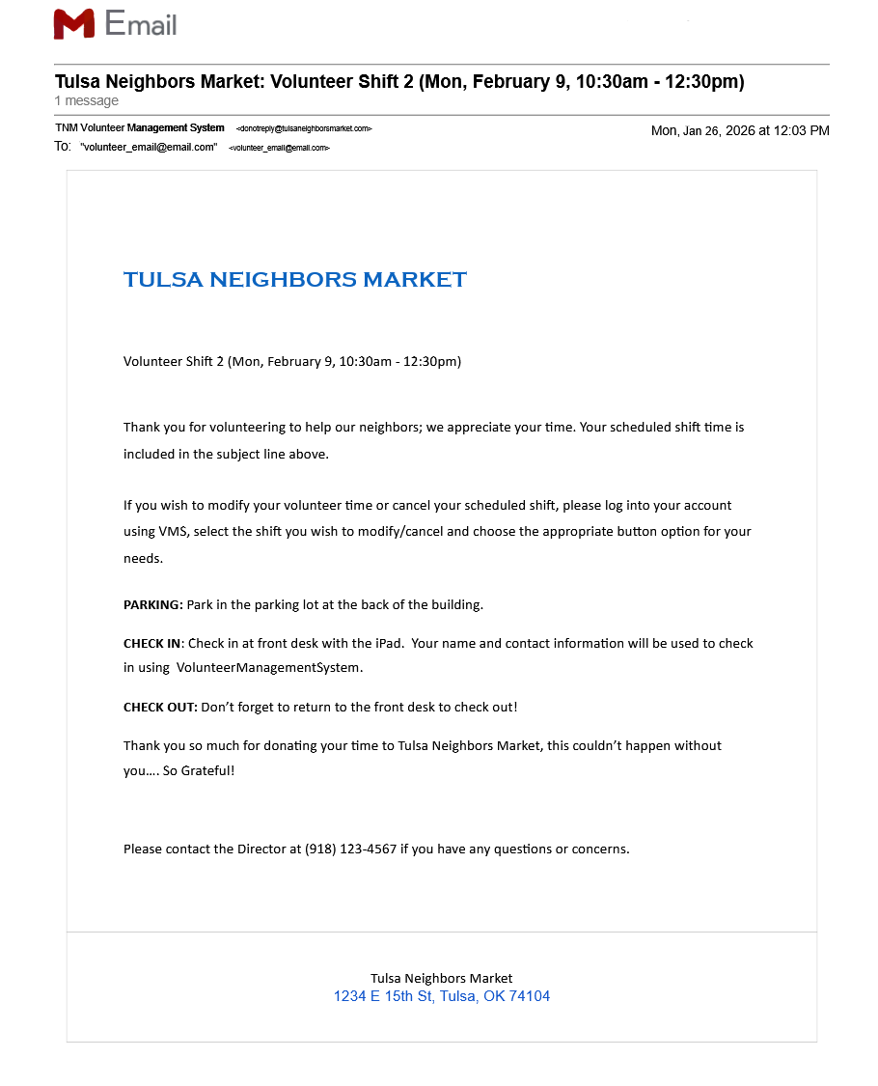
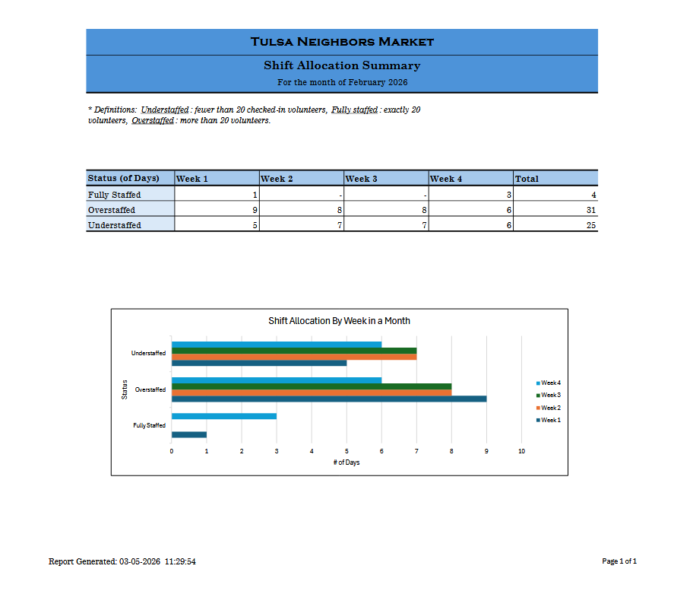
Output 2: Report 4_Shift Allocation Summary

Output 3: dashboard showing the volunteer sign up in totals by each time slot up to four weeks in advance
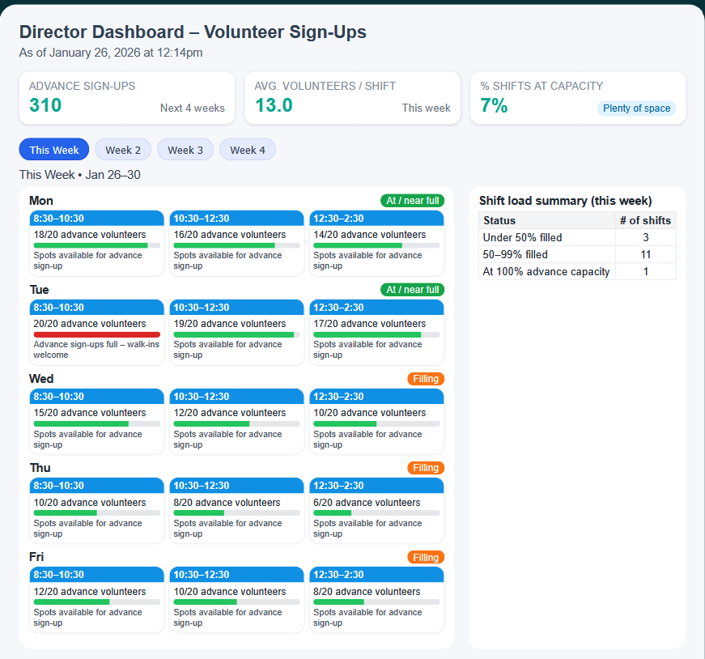

Output Data Dictionaries
Name: Volunteer shift Email Confirmation

Medium: Email

Special Instructions:
- Subject Line is dynamically generated as “Volunteer Shift # (Day, Month Day, Time – Time”
- Email pulls volunteer name, shift date and shift times
- Parking, Check in and Check out are static text
- Email must be sent as a no reply address
- Times are formatted in 12-hour format
- New email is generated if shift details changes

Input Label | Element Name | Table Name | Edit Mask | Editing / Validation
Shift name | Shift_type | Shifts | Text (20) | Match stored organization name.
Shift Date | Date_Month, Date_Day_Of_Match, Date_Year | Schedules | MM/DD/YYYY | Email format
Sender Display Name | Organization_Name | Group Members | Text (25) | Must match stored organization name
Recipient Email | Volunteer_Email | Volunteers | Text (30) | Must be valid email format, must exist for the selected volunteer
Sender Email | Organization_Email | System Generated | Text | Must be valid email format
Email Subject Line | Shift_Subject_Line | System Generated | Text | “Volunteer Shift X (DD/MM, Start-End)”. Must match a scheduled shift
Organization Header Title | Organization_Name | Group Members | Text | Printed as stored
Shift Start Time | Shift_Start_Time | Shifts | HH:MM AM/PM | Must be valid time
Shift End Time | Shift_End_Time | Shifts | HH:MM AM/PM | Must be valid time
Volunteer First Name | Volunteer_Name_First_Name | Volunteers | Text (25) | Has to match records
Volunteer Last Name | Volunteer_Name_Last_Name | Volunteers | Text (25) | Has to match records
Instructions | Modify_Shift_Instructions | Static | Text | Hard-coded instructional text
Parking Instructions | Parking_instructions | Static | Text | Hard coded
Check in instructions | Check_In_Instructions | Static | Text | Hard Coded
Check out instructions | Check_Out_Instructions | Static | Text | Hard Coded
Director Phone Number | Organization_Phone | System Generated | Phone nr | Valid Number (US or other country)
Organization Address Street | Volunteer_Address_Street or Organization_Street | Volunteer and Group Members | Text (25) | Must be valid stored address
Organization Address City | Volunteer_Address_City or Organization_City | Volunteer and Group Members | Text (20) | Must be valid and stored
Organization Address State | Volunteer_Address_State or Organization_State | Volunteer and Group Members | Text (2) | Must be valid US state code
Organization Address Zip Code | Volunteer_Address_Zip_Code or Organization_Zip | Volunteer and Group Members | 5-digit ZIP (5) | Zip code format

Name: Shift Allocation Summary

Medium: Printed PDF

Special instructions
- Includes definitions of staffing levels
- Weekly counts are based on the volunteers checked in per shift
- Reports include horizontal bar charts
- Totals are automatically calculated
- Data should be filtered monthly

Input Label | Element Name | Table Name | Edit Mask | Editing / Validation
Organization Name | Organization_name | Group Members | Text | Match existing organization record.
Report Title | Report_Title | Report | Text | No edit
Report monthly | Date_Month | Schedules | Number (2) | Valid 1-12 integer or month name
Status Category | Shift_type | Schedule | Text | <20 = understaffed, =20 = fully staffed, >20 Overstaffed
Week Number | Week_Number | Schedules | Integer (1-4) | Derived from Date_Day_Of_Month using weekly grouping rules
# of Days | Days_Count_By_Week_Status | System generated | Integer | Count Schedule_IDs per week meeting status definition
Total Days | Days_Count_Total_Status | System Generated | Integer | Must be equal sum of all weekly counts for that status
Chart Status Labels | Status_Category | System Generated | Text | Must match one of the staffing alternatives
Chart Week Series | Week_Number | System generated | Integer | Must be between 1-4
Chart Display Values | Days_Count_By_Week_Status | System generated | integer
Report Generated Timestamp | Report_Generated_Timestap | System generated | MM-DD—YYYY HH:MM:SS | Must be valid date and time
Page Number | Page_number | System generated | N of m | System generated

Name: Director Dashboard

Medium: Interactive Dashboard

Special instruction:
- Display changes as the view is changed, This week, week 2 etc
- Some specific values are calculated in real time
- Color coding for capacity <50% filled --> Blue, etc
- Shift load summary must reflect counts for the selected week only
- Volunteer counts are derived from pre-registrations and sign-ups
- Dashboard timestamp at exact moment of refreshed

Input Label | Element Name | Table Name | Edit Mask | Editing / Validation
Report Timestamp | Dashboard_Timestamp | System Generated | MM/DD/YYYY HH:MM AM/PM | Must be valid system datetime, Auto-generated
Advance Sign-Ups | Advance_SignUps_Total | System Generated from shifts + Volunteers | Integer | Count of volunteers with Sign_In_Time
Avg Volunteer per shift | Avg_volunteers_Per_Shift | System Generated | Decimal | Computed: total volunteers ÷ total shifts.
% Shifts at Capacity | Percent_Shifts_At_Capacity | System Generated | Percent | Shifts with advance volunteers = Slots_Available ÷ Total shifts
Week Selector Buttons | Week_Number | Schedules | Integer | From data range of selected week. (1-4)
Selected Week Date Range | Week_Date_Range | Schedules | Text | From Date_Day_Of_Month, Date_Month and Date_Year.
Day Header | Day_Of_Week | Schedules | Text | Derived from date
Shift Time Range | Shift_Start_Time / Shift_End_Time | Shifts | HH/MM – HH/MM | Must be a valid time
Advance Volunteer Count | Advance_SignUps_Count | System Generated from Shifts and volunteers | integer | Count of volunteers pre-registered for the shift. (Between 0 and slots avalible)
Capacity Indicator | Shift_Capacity_Display | System Generated | ##/## | Derived from Advance_SIgnUps_Count and Slots_Availabile
Available Spots Message | Spots_avalible_Message | System Generated from Slots avalible – advance_SIgnUps_Count | Text | If Remaining > 0 → Display spots availabe
Capacity Status | Capacity_Status | System Generated | Text | <50% plenty space, 50%-99% = filling,  100% = Near Full
Slots Available | Slots_Available | Shifts | Integer | Must be ≥ 0
Shift Load Summary <50% | Shifts_Under_50 | System Generated | Integer | Advanced SignUps Count / slots avalible <50%
Shift Load Summary  50%-99% | Shifts_50_to_99 | System Generated | Integer | 0.5 ≤ ratio ≤ 1.00
Shift Load Summary  100% | Shifts_At_100 | System Generated | Integer | Ratio = 100
Summary Status Lables | Summary_Status_Labels | Static | Text | Must match Values

Prototypes of Inputs

Input 1: Enter New Contact Info

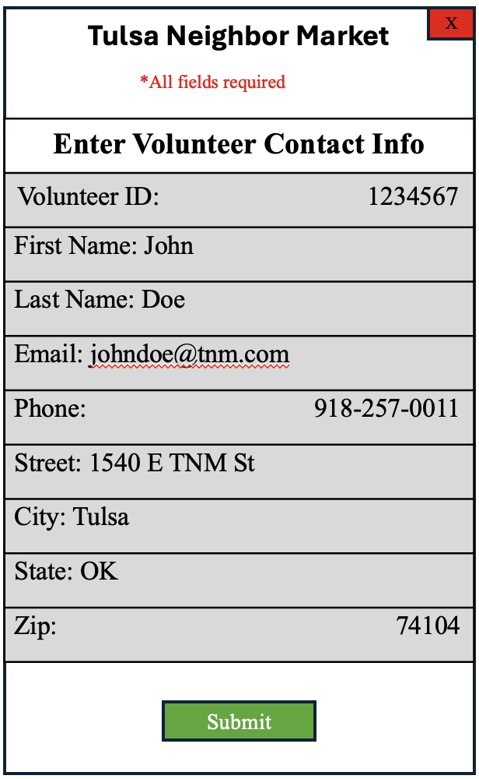

Input 2: Enter Number of Volunteers

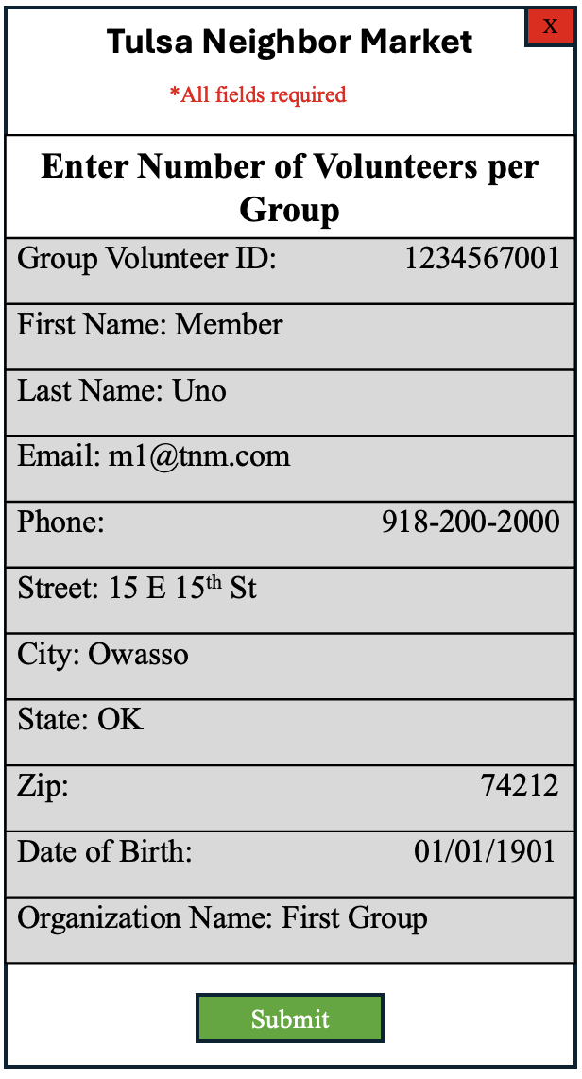

Input 3: Enter Additional Volunteer Info

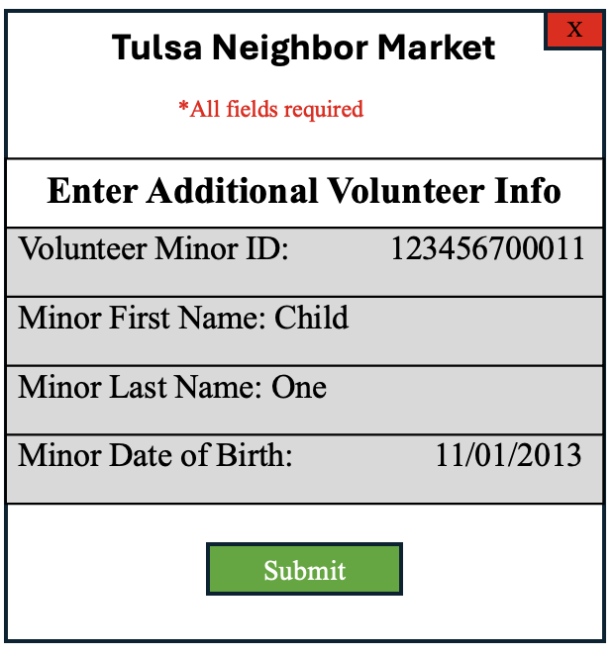

Input Data Dictionaries
Name of Input: Enter New Contact Info (Corresponding data flow: New volunteer contact)
Description: This input allows users to enter new contact information to the existing contact information.
Medium: A tablet/iPad
Special Instructions: N/A

Input Label | Element Name | Table Name | Edit Mask | Editing / Validation
Volunteer ID | Volunteer_ID | Volunteers | Number (7) | System Generated
First Name | Volunteer_Name_First_Name | Volunteers | Text (25) | Must be entered
Last Name | Volunteer_Name_Last_Name | Volunteers | Text (25) | Must be entered
Email | Volunteer_Email | Volunteers | Email (30) | Must be entered
Phone | Volunteer_Phone_Number | Volunteers | Number (10) | Must be entered
Street | Volunteer_Address_Street | Volunteers | Text (25) | Must be entered
City | Volunteer_Address_City | Volunteers | Text (20) | Must be entered
State | Volunteer_Address_State | Volunteers | Letter (2) | Must be entered  Must be valid 2-digit state code
Zip | Volunteer_Address_Zip | Volunteers | Number (5) | Must be entered  Must be valid 5-digit zip code
Date of Birth | Volunteer_Date_Of_Birth | Volunteers | Date (10) | Must be entered  Must be in MM/DD/YYYY format

Name of Input: Enter Number of Volunteers (corresponding data flow: Group member instance)
Description: Allows users to enter the number of volunteers that will be signing up, including whether they are an individual or with a group.
Medium: A tablet/iPad
Special Instructions: N/A

Input Label | Element Name | Table Name | Edit Mask | Editing / Validation
Group Volunteer ID | Volunteer_ID_Group_ID | Group Members | Number (10) | System Generated
First Name | Group_Member_Name_First_Name | Group Members | Text (25) | Must be entered
Last Name | Group_Member_Name_Last_Name | Group Members | Text (25) | Must be entered
Email | Group_Member_Email | Group Members | Email (30) | Must be entered
Phone | Group_Member_Phone_Number | Group Members | Number (10) | Must be entered
Street | Group_Member_Address_Street | Group Members | Text (25) | Must be entered
City | Group_Member_Address_City | Group Members | Text (20) | Must be entered
State | Group_Member_Address_State | Group Members | Text (2) | Must be entered  Must be valid 2- digit State code
Zip | Group_Member_Address_Zip_Code | Group Members | Number (5) | Must be entered  Must be valid 5- digit zip code
Date of Birth | Group_Member_Date_of_Birth | Group Members | Date (10) | Must be entered.  Must be in MM/DD/YYYY
Organization Name | Organization_Name | Group Members | Text (25) | Must be entered

Name of Input: Enter Additional Volunteer Info (Corresponding data flow: New minor profile)
Description: Adults who are volunteering with a minor can enter the minor’s information and link it to the adult’s account.
Medium: A tablet/iPad
Special Instructions: N/A

Input Label | Element Name | Table Name | Edit Mask | Editing/Validation
Volunteer Minor ID | Volunteer_ID_Minor_ID | Minors | Number (12) | System Generated
Minor First Name | Minors_Name_Minor_First_Name | Minors | Text (25) | Must be entered
Minor Last Name | Minors_Name_Minor_Last_Name | Minors | Text (25) | Must be entered
Minor Date of Birth | Minors_Date_of_Birth | Minors | Date (10) | Must be entered

Prototype of Entire Navigation System
Volunteer:
Main Menu

Check In/Out Update Information Mark Arrival Enter New Address
Mark Departure Enter New Phone Number
Enter New Email
View Available Shifts Modify Shift Sign Up for Shift Cancel Shift Sign up for Multiple Shifts

Director/Manager:
Main Menu
View Report
View Volunteer Totals
View Unique Volunteers
View Individual/Group Volunteer Hours
View Shift Staffing Status

Appendix
Prepared for

Tulsa Neighbors Market

Prepared By Systems Analysis Team 2:
Anna Boevers, Trinyon Gaylor, Alexia Glory, Joe Pennington, Timothy Carlsson Seger and Jaden Worrell

M2 Appendix: Interview Request

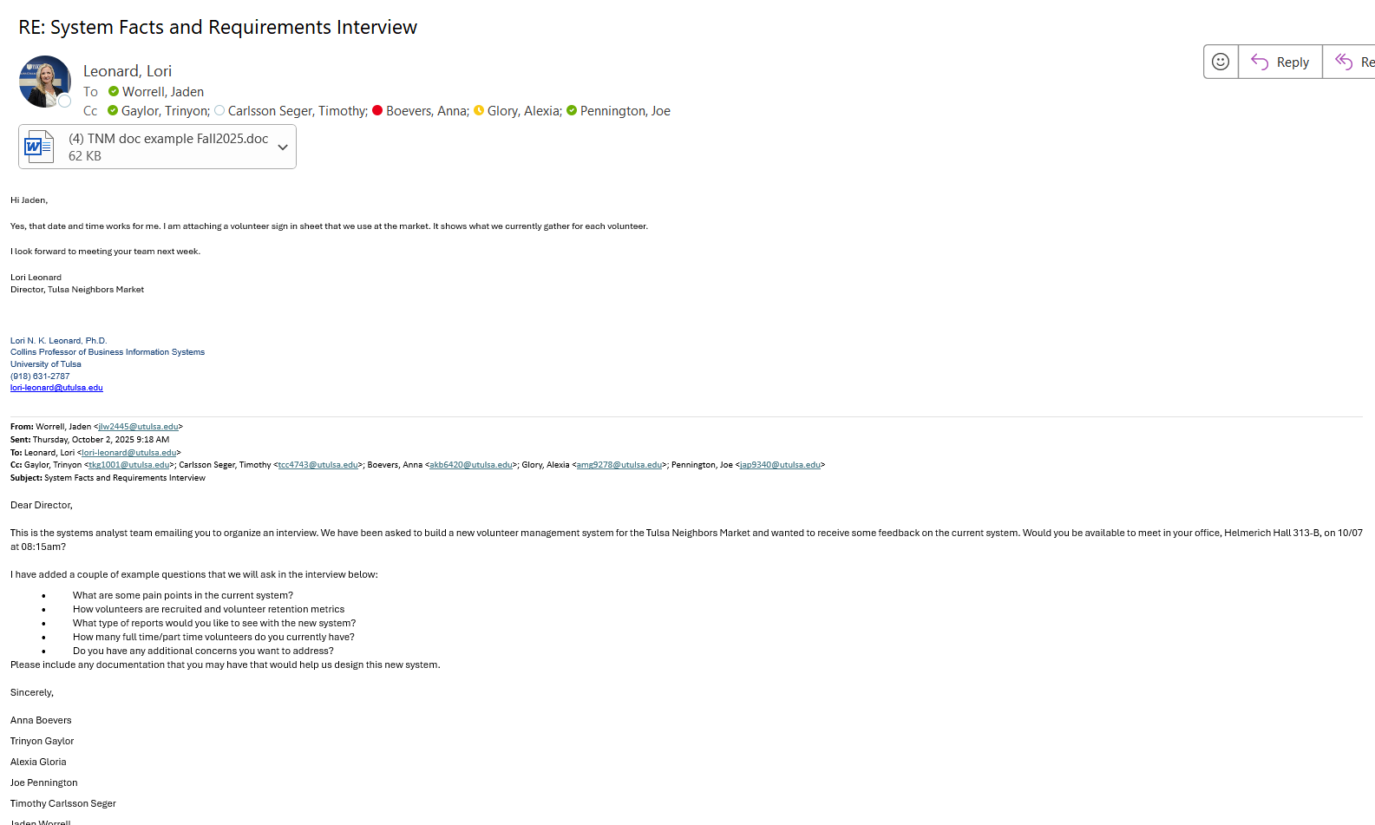

M2 Appendix: Interview Reminder
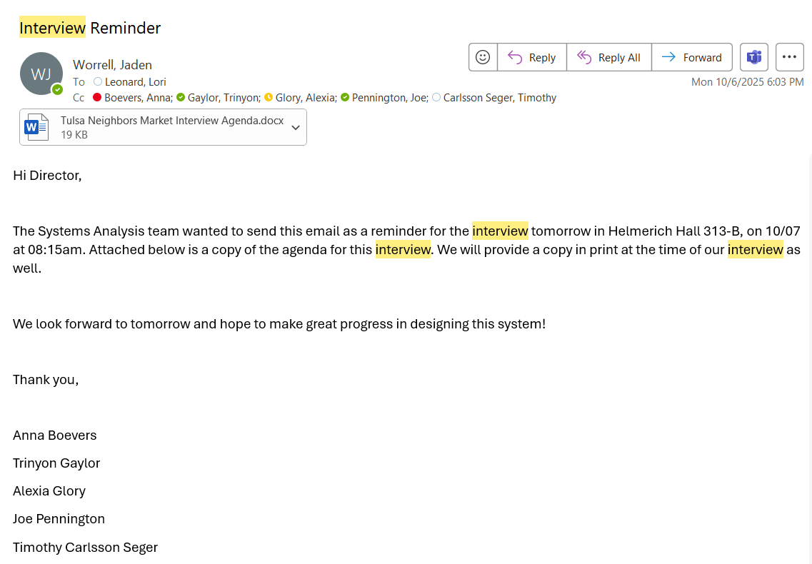

M2 Appendix: Interview Agenda
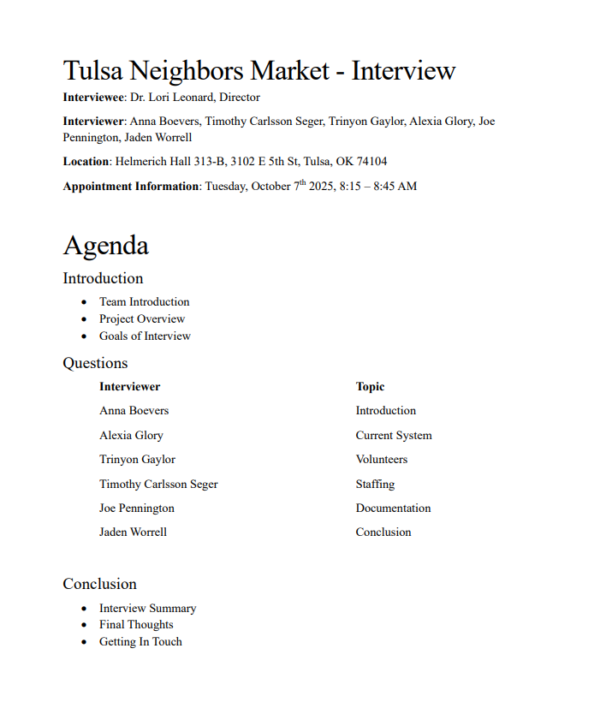

M2 Appendix: Interview Summary Email
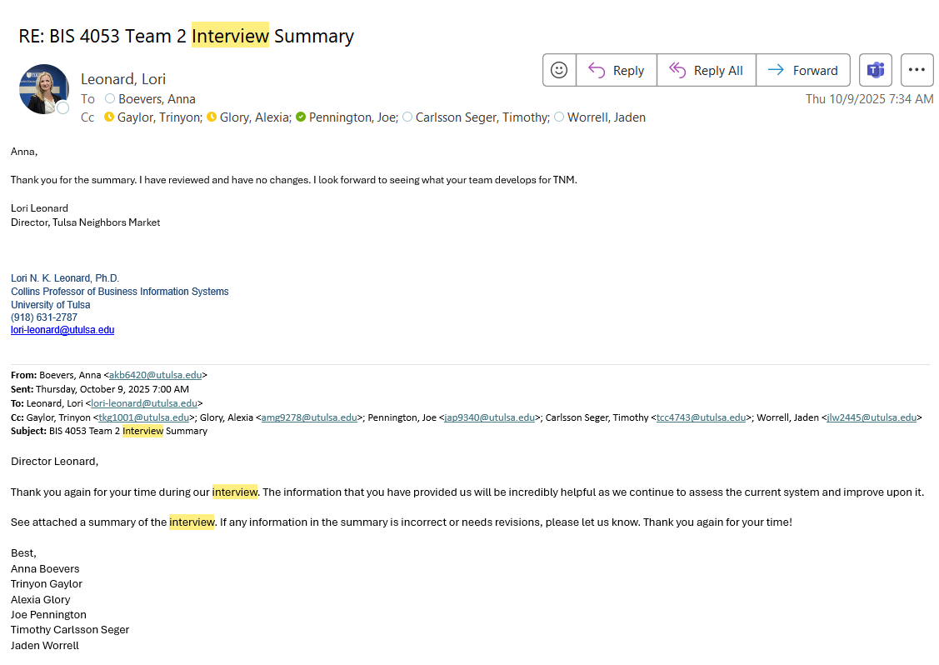

M2 Appendix: Interview Summary
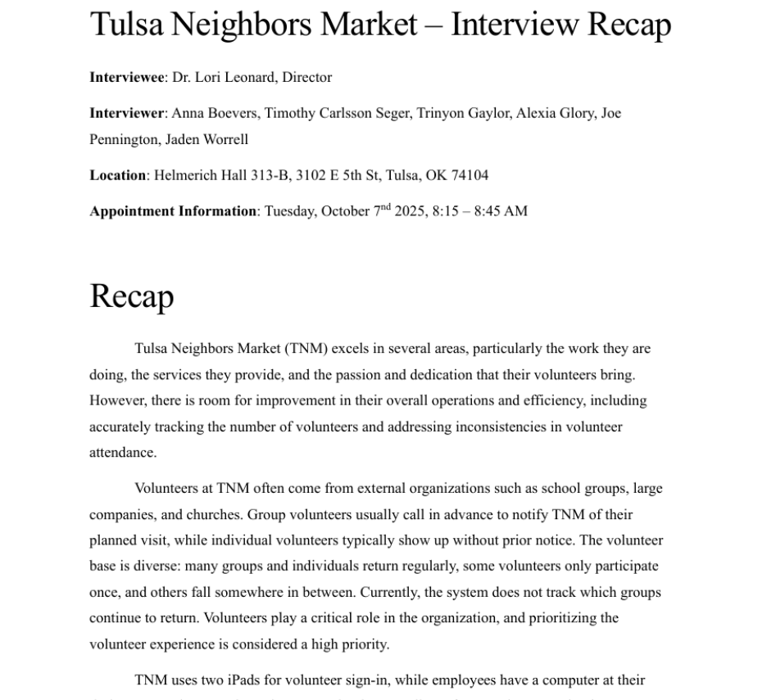
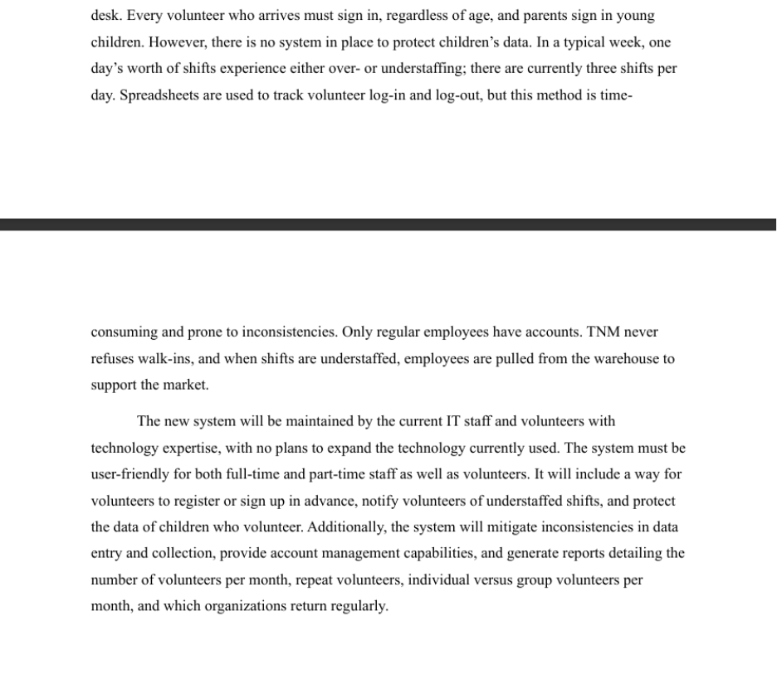

M2 Appendix: Questionnaire Request
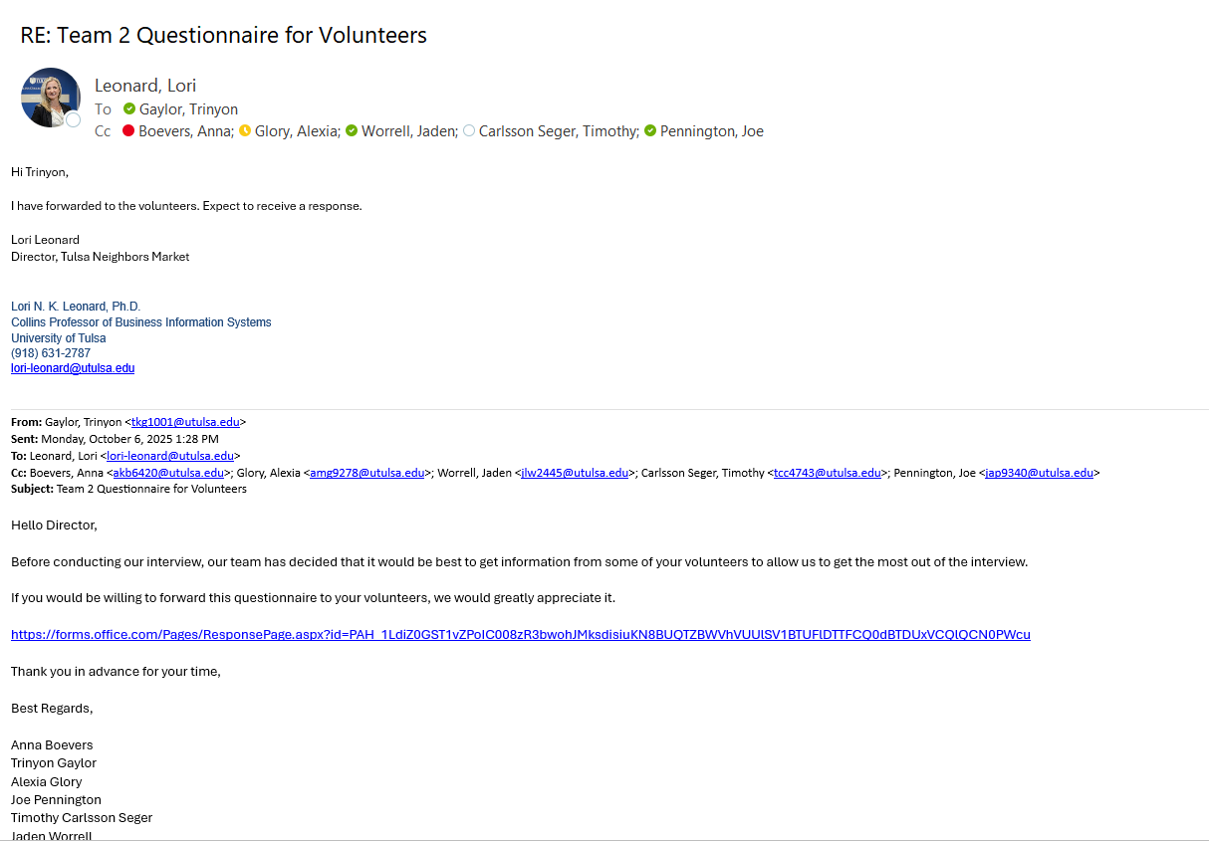

M2 Appendix: Questionnaire
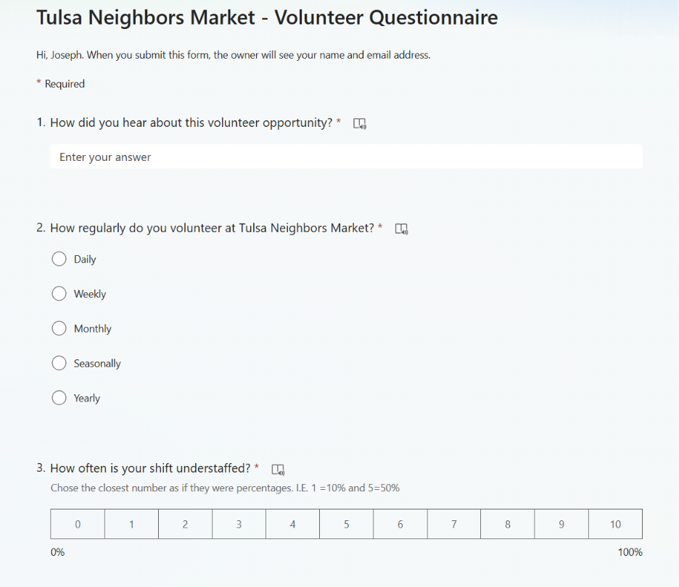
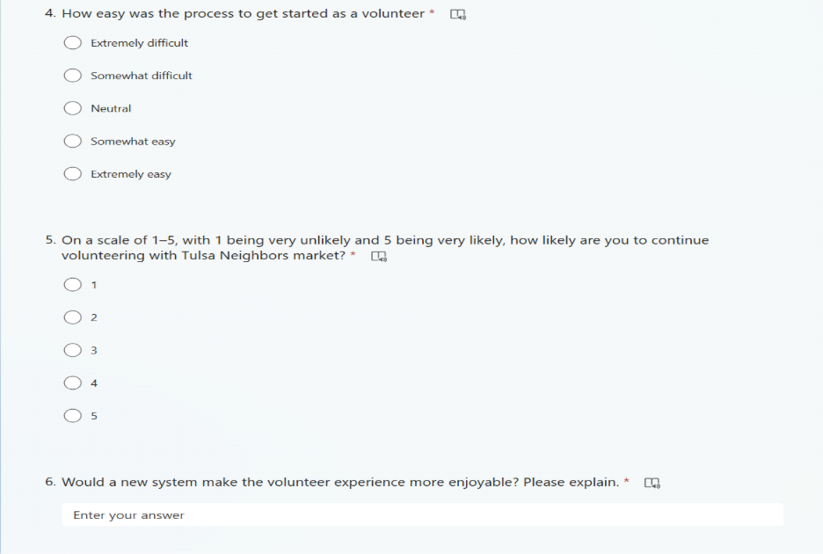
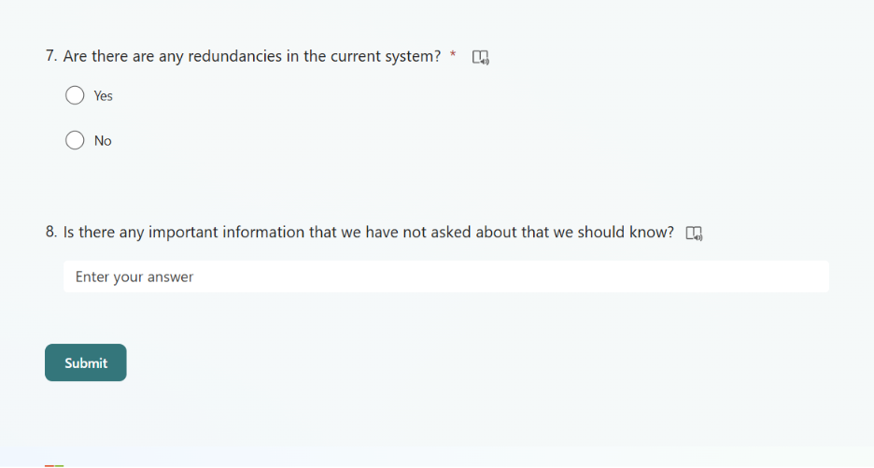

M2 Appendix: Questionnaire Response
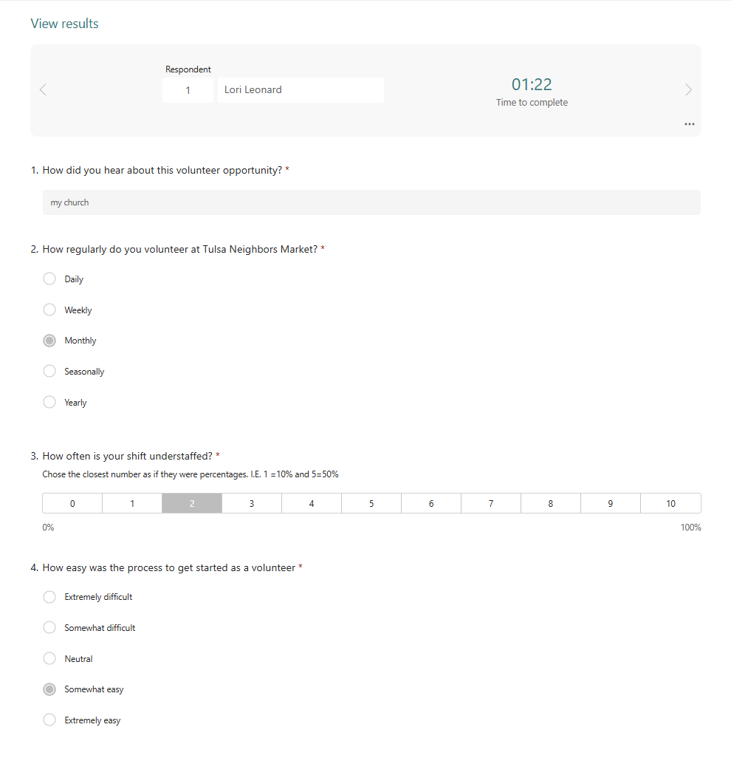
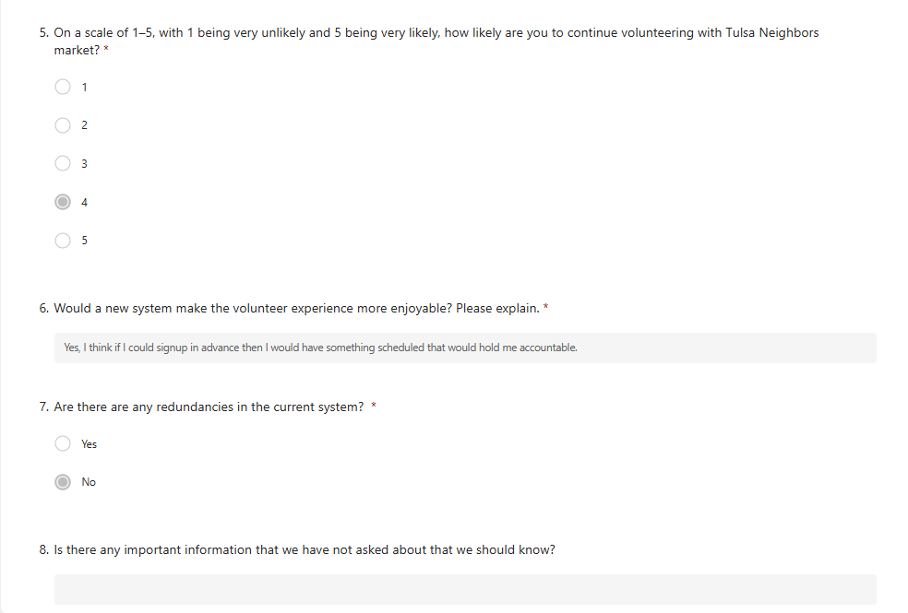

M2 Appendix: Sample Document
